RESEARCH COMPILATION

APRIL 6, 2019

SHOWKER TEAM OCTOPUS

Table of Contents

Table of Contents 1
Introduction 2
Research Methods 2
Data: Survey 3
Data: Focus Groups 6
Conclusion 7
Appendix: Trial Research 8
Authors 10

Introduction

The purpose of this research project was to gather information on how students, faculty, and staff at Bridgewater College view campus communication, especially as it pertains to the student portal, MyBC, and what changes they would like to see made. The goal was to then analyze this research, and create a set of recommendations for how campus communication at Bridgewater College can be improved. Finally, the entire body of work, including both research and recommendations, would be presented to the school, primarily to the Student Life Department and IT Center, with the hope that they will be able to use it to benefit the school by taking steps to improve communication and engagement on campus.

Research Methods

Showker Prize Competition Team Octopus (“the team”), consisting of eight students, approached this research through a variety of ways.

- First, the team spent some time looking at other schools’ student portals and talking to students at other colleges. Through this research, the team was able to get a sense of what has, and has not, worked well for other schools, and what features students do, and do not, like about their portals.
- The team created a ten-question online survey for students. The survey included six multiple choice questions, and four short-answer questions. This survey was distributed to Bridgewater College students in two ways:
  - The survey was posted on the “Ernie’s List” section of MyBC. First posted on January 19, 2019, the survey was kept on Ernie’s List for around three weeks.
  - In addition, the team set up a table in the KCC lobby on two different occasions. Both times, the team set up laptops at the table, and invited students to take the survey. As an incentive, students who took the survey at the table were entered in a raffle for Bridgewater apparel.
- The next method the team used was focus groups.
  - Student focus group: Advertised through a Campus Bulletin post, students were invited to participate in a focus group with other students and Team Octopus as facilitators. This gave students an opportunity to share their thoughts and suggestions.
  - Faculty/Staff focus group: Similar to the student focus group, faculty and staff were invited to share their thoughts and participate in a discussion about campus communication and what improvements could be made.

Data: Survey
A link to the full survey is located here.

The following is a sample of our data:
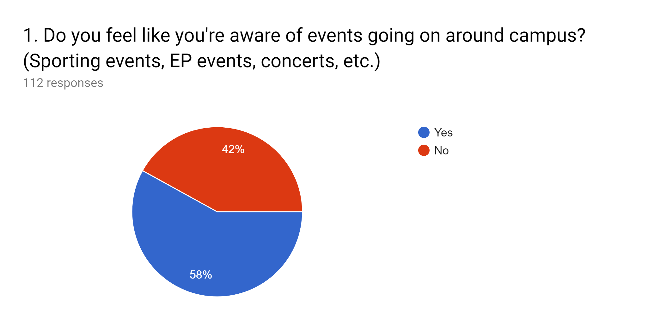
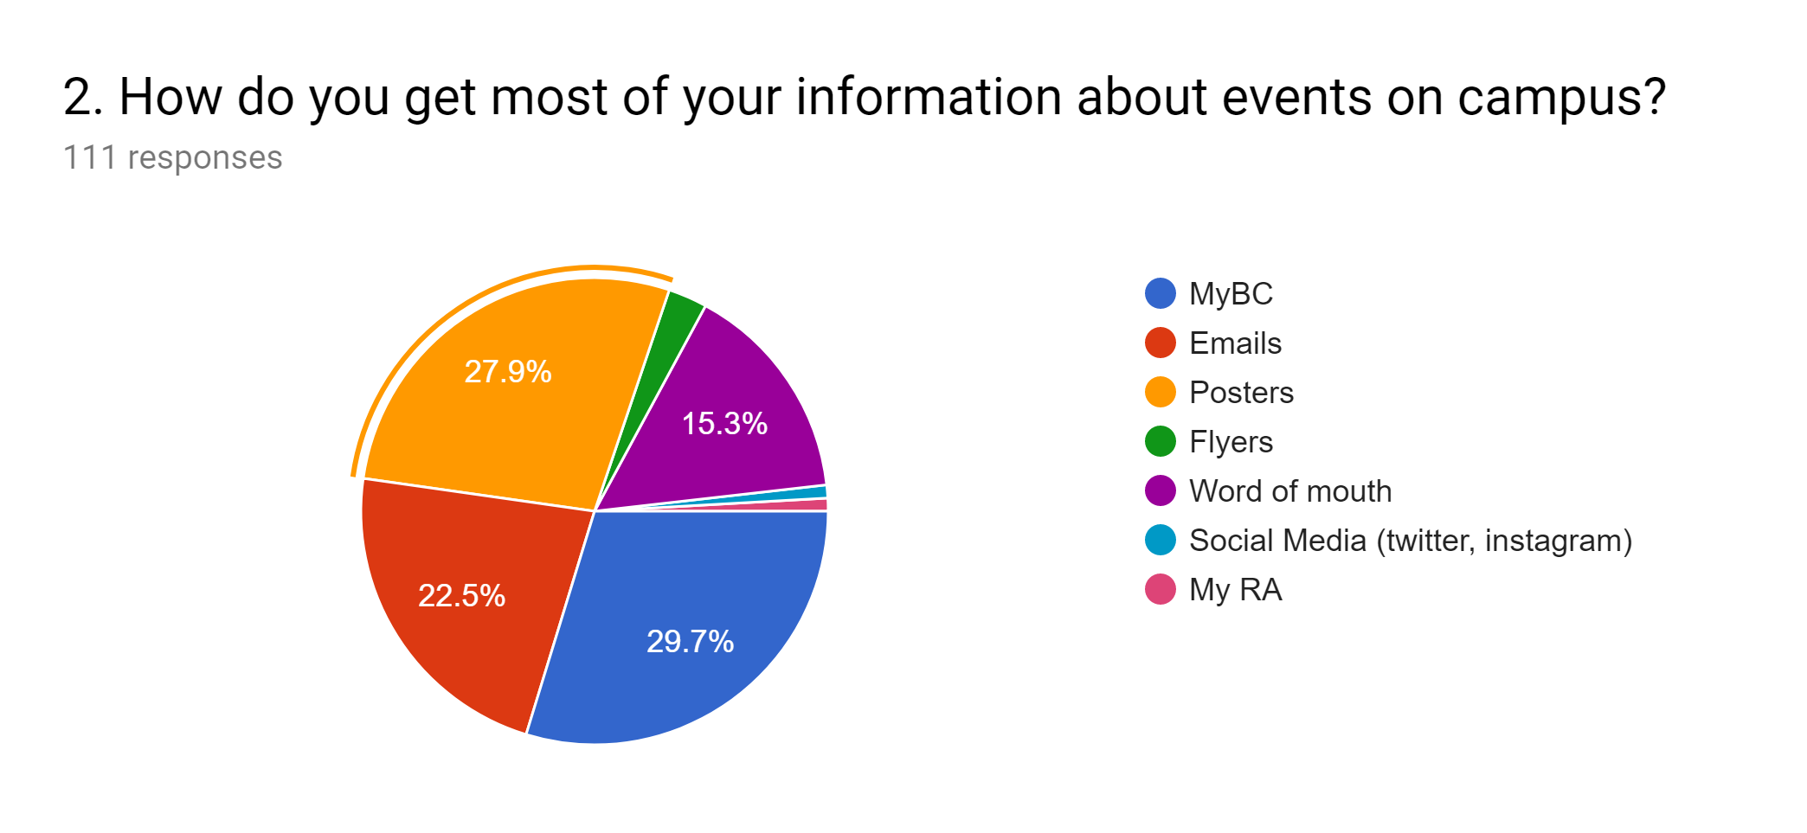
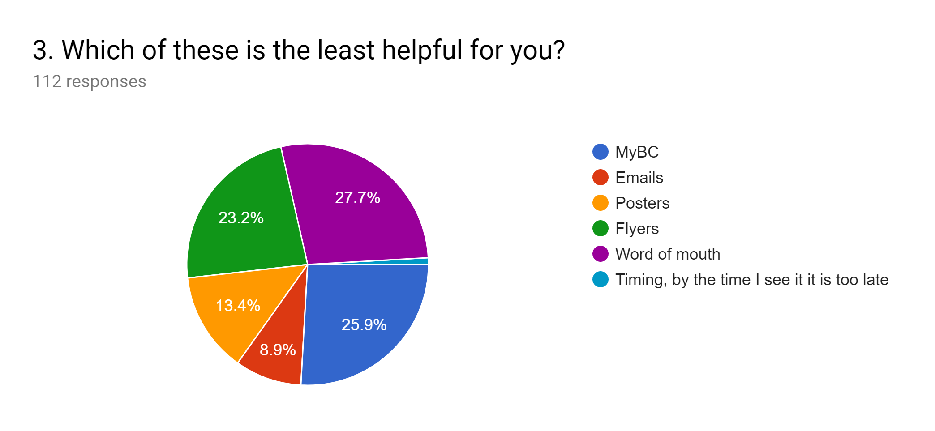
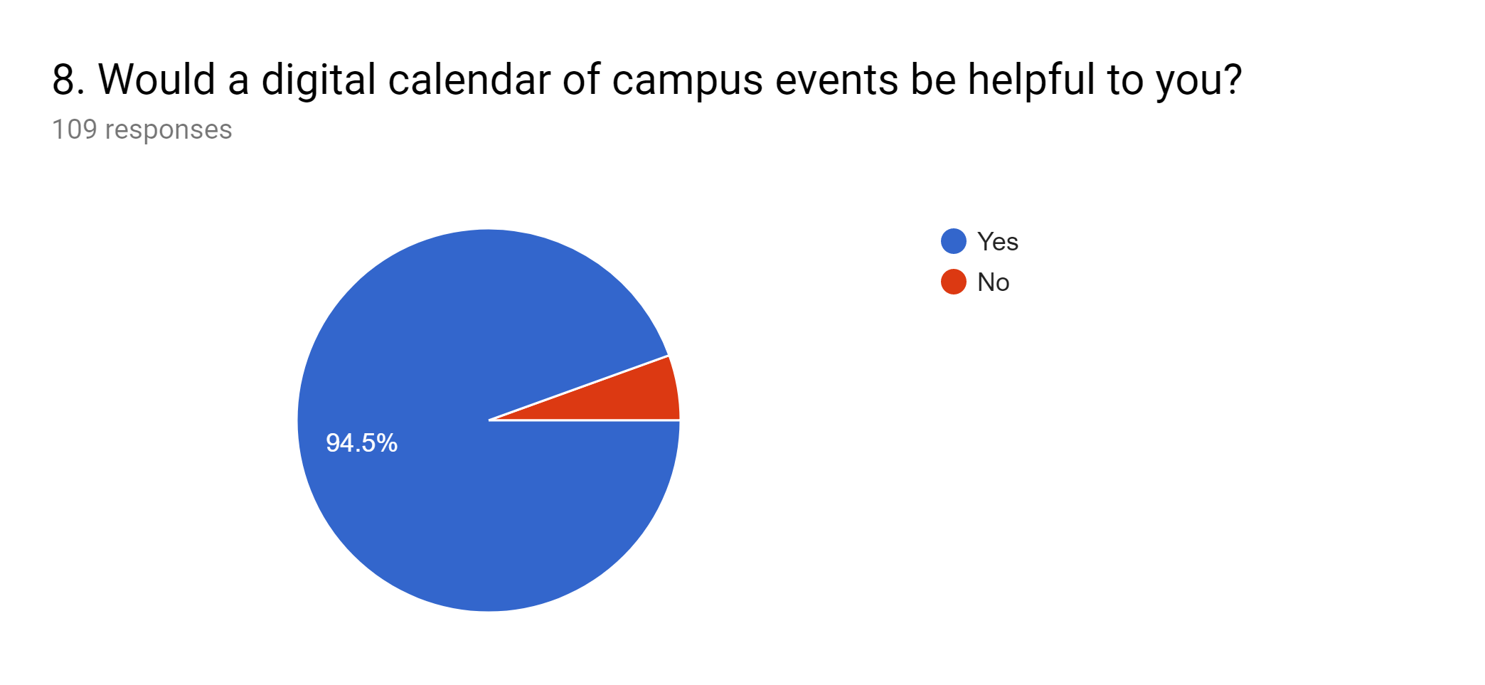

The following are a sample of fill-in-the-blank responses:

5. How do you think communication on campus can be improved?
- By creating some form of master event list available on mybc or an app.
- Communication is next to none when it comes to notifying commuters.
- By having everything in one place.
- Make the campus bulletin more accessible.
- Overall, just keeping things updated so that students know what's happening.
- Weekly email with all events on campus, location, date, and time as a list.
- Making campus information about events available online. Commuter students never see flyers or hear about things.

6. Are there any ways you think communication through MyBC could be improved?
- Put the events box in a more noticeable position.
- Divide it up slightly more along subject. There are still pretty broad categories.
- Post upcoming events and details about it not just the event title.
- Create a weekly email with all events on campus, location, date, and time as a list. They don't need to be organized by event type...but just by day of the week and time of day.
- Show a calendar of all the school's events instead of having to click on each individual event.
- Maybe have a bolded section just for sports events, one for convos, etc. It would let students find what they're interested in easier.
- Don't put all the announcements at the bottom of the page.

7. Are there any features you would like to see added to MyBC?
- event list is easily accessible.
- club and event folders.
- a calendar of events and their information for ease of access.
- A uniform events page.

9. Any additional comments/feedback?
- MyBC needs to be updated. Several sections are lacking current information and aren't up to date. There are also several sections that aren't as well developed as they could be concerning information.

Data: Focus Groups

Student Focus Group:
February 6

- EP is good at advertising events, but most other events there is not enough advertising; often don’t find out about events until too late
- MyBC is effective to some extent, but could use improvements
  - The categories are confusing
  - The layout is awkward and dated
  - Needs a more attractive layout; something to grab people’s attention
- A master events calendar would be very helpful, whether in an online or hard-copy form
- An app would also be very useful (need Android version)
- Some students want fewer emails
- Some students want more emails (would rather have too much information than not enough)
- Platforms already setup should be better utilized (such as Facebook, Instagram, etc.)
- Posters are most effective in the KCC and bathrooms, less effective in the Funk or Link

Faculty and Staff Focus Group:
February 27th

- Don’t know if anyone sees MyBC posts, very limited software programs
  - Bolding, presentation issues
  - Interface problems
  - Fonts and accent issues with typing
- MyBC needs to be USER FRIENDLY
- Time that the daily email is sent out (should be earlier in the day)
- MyBC not effective, not checked periodically
- Competition for events, hard to compare; “getting attention is half the battle”
  - Since requirements to attend convocations were eliminated, participation has been down
  - Calendar may help prevent overcrowding events onto specific days
- Not understanding the differences between events, campus activities (MyBC categories)
- Calendar (current format on website) needs a lot of work (time and locations)
- Ad Blocker does not allow MyBC to work on phone
- Requires a lot of energy to get attention
  - Flyers and MyBC are not getting the attention they need
- Personalization factor is important
- No auto-refresh ability

Conclusion

Based on the research conducted, the following are suggestions that Team Octopus makes to increase Bridgewater College campus communication effectiveness:

- A multi-user calendar to be added to MyBC with distinction between academic, athletic, and social events.
- A student-friendly app.
- Events displayed on the school website should include more information than just the date and time.
- Frequent removal of old posters and updates of relevant ones.
- A well-advertised weekly email with a list of events occuring on campus, rather than the current daily model.

Appendix: Trial Research

After analyzing the original research and debating the conclusions drawn, a prototype calendar was developed to test the effects that it may have on campus communication. The app Teamup Calendar was used to host our prototype. This was then sent out to fifteen students, across varying classes, majors, and involvements. They were given one week to use the prototype, with the requirement of participating in a survey at the end of the trial period. A drawing for forty dollars was used to incentivize participation as well. A link to the full survey is located here. The data is as presented below:

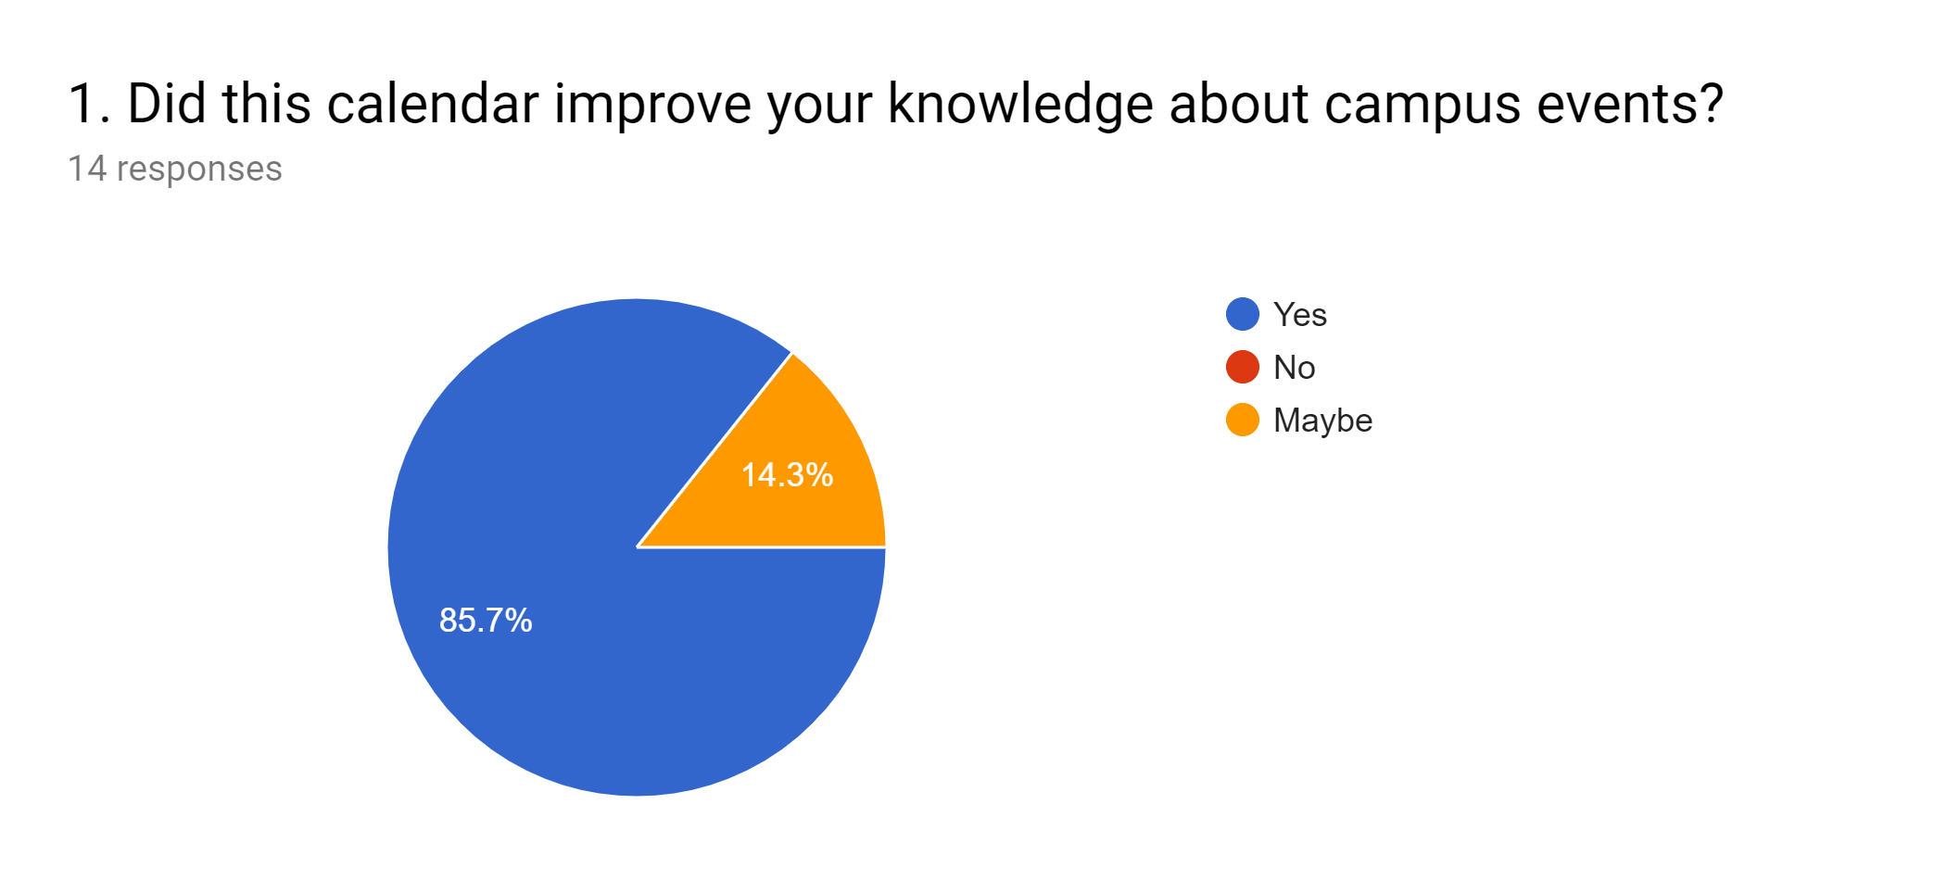
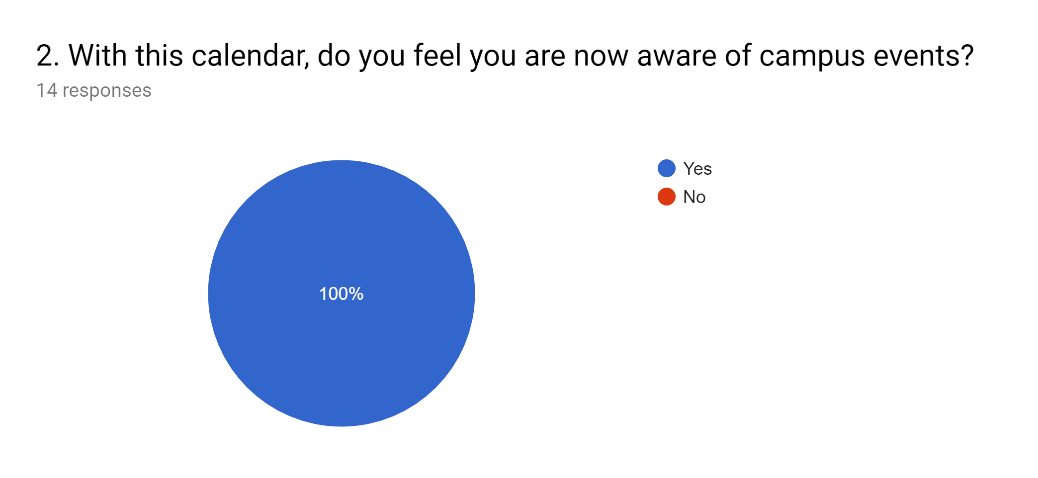
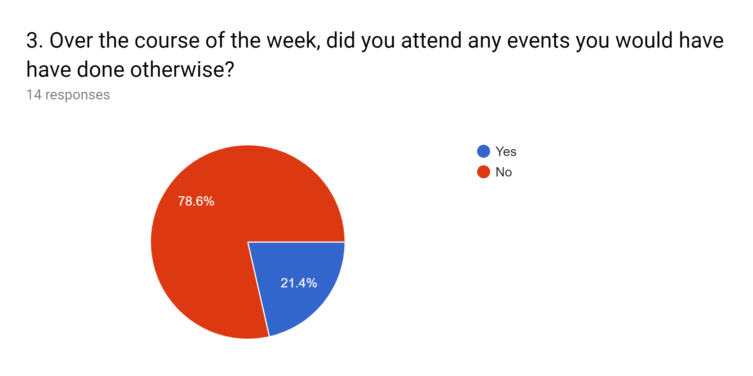
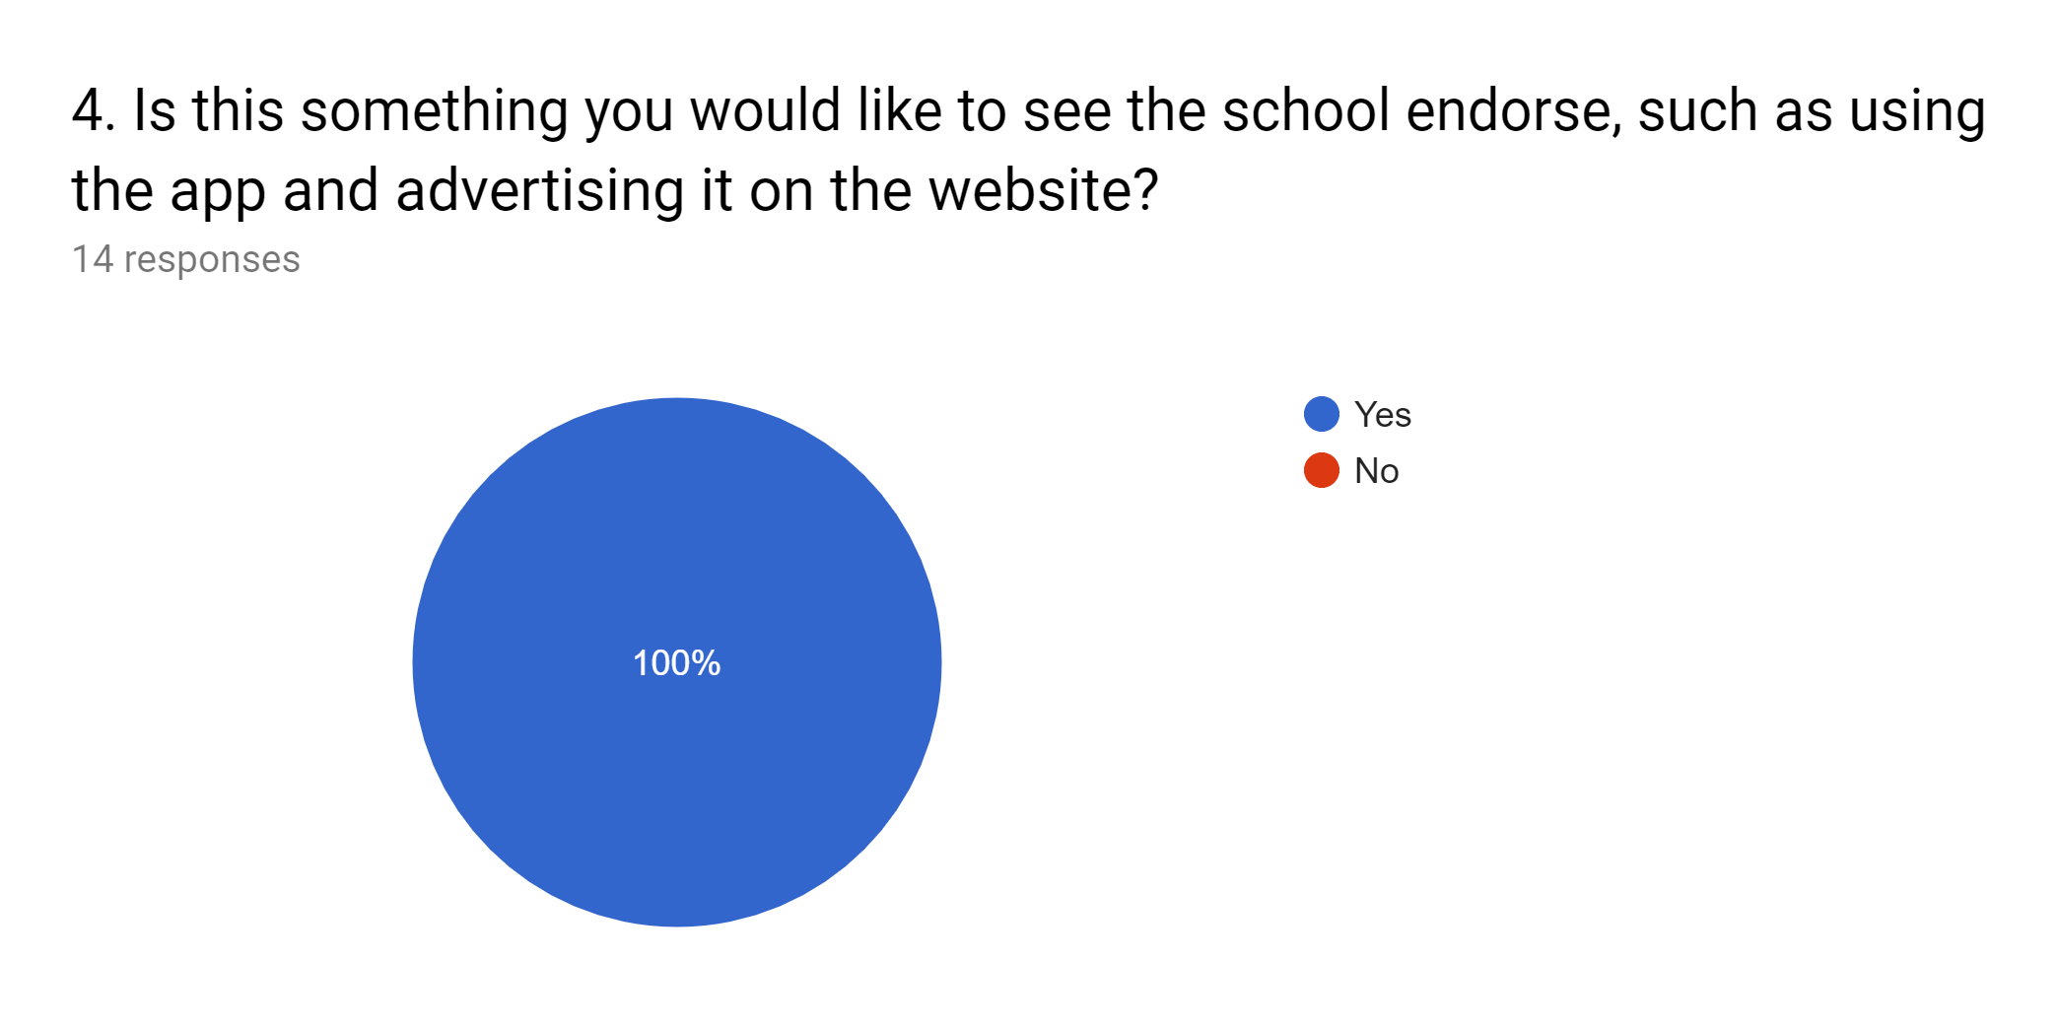
The following are examples of recommendations for improvement:

5.
- Some of the events had details posted and others did not. If they consistently told you where and when things were happening with a brief description I think it would help a lot.
- Maybe talk to the clubs and see if they want to add their events as well.
- Make it so I can add my own stuff on my calendar. I would like to be able to edit it.

Authors
Showker Prize Competition 2019

Team Octopus: showkerteamoct@gmail.com.

Ben Chatterton
Erin Dietz
Matthew Gordon
Ben Hancock
Dan Hancock
Samantha Hince
Olivia Kloster
Jarod Stickley

