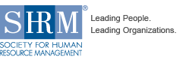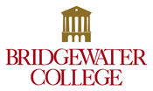

[Type a quote from the document or the summary of an interesting point. You can position the text box anywhere in the document. Use the Drawing Tools tab to change the formatting of the pull quote text box.]

[Type a quote from the document or the summary of an interesting point. You can position the text box anywhere in the document. Use the Drawing Tools tab to change the formatting of the pull quote text box.]

**Fall Semester Events**

* Dress Down Fundraiser to help fund some of our Fall and Spring Events
* SHRM tours Mount Crawford Creamery! September 24th at 3:30 pm.

Upcoming Events

* SHRM-O-Ween at Lou’s
* Mock Interviews

..More Business Tours

**HR FACT**

**Over 75% of resumes are discarded due to unprofessional email addresses**.

**“Empowering people to do their best at all stages of their lives, regardless of their industry, background, or culture, leads to innovation, a higher quality of work, more employee commitment, and resulting higher productivity.” ---Hank Jackson, SHRM CEO**

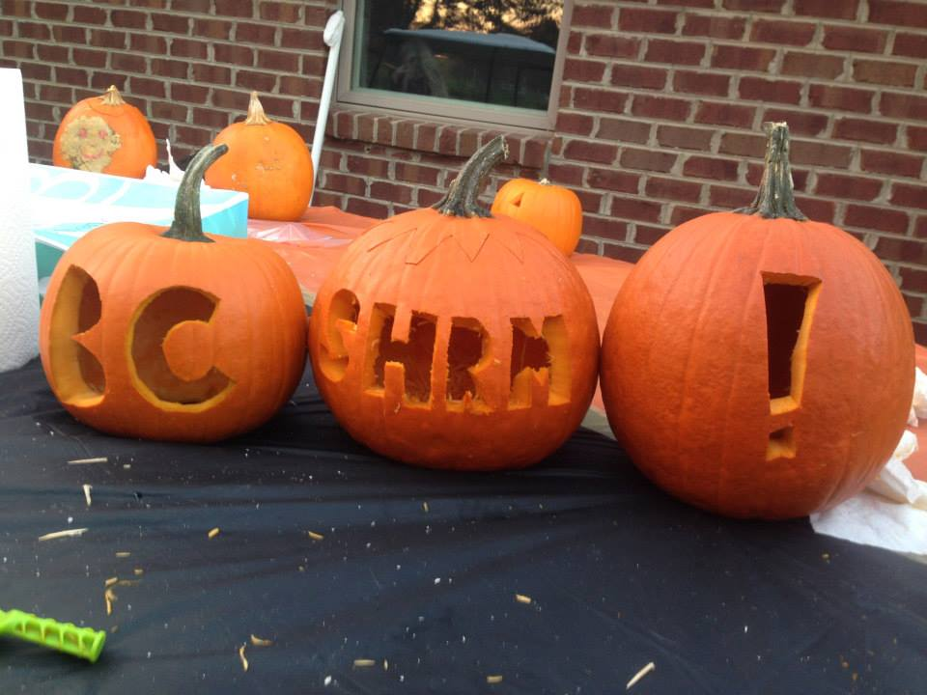

(Left): Our beautifully sculpted SHRM pumpkin. (Below): Last year’s Mt. Crawford Creamery tour, led by Frank Will, where we observed its processing plant, HR operations, and even pet baby calves! A special thank you to the Will brothers for hosting us.

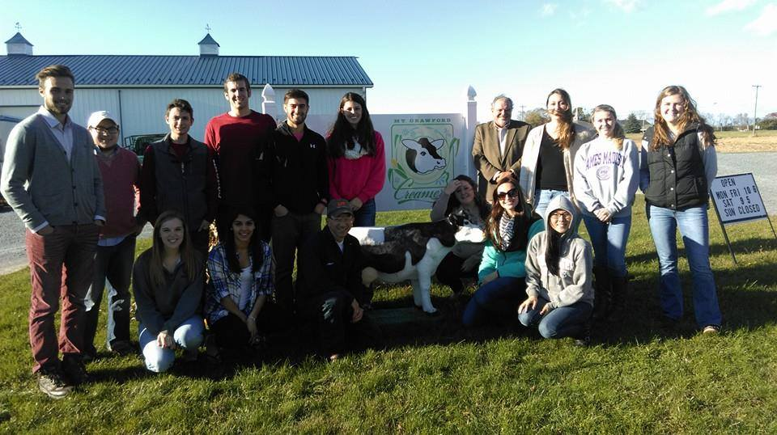

(Below): Advisor Dr. Pugliese, Bridgewater College President Bushman, and SHRM members at last year’s dinner and discussion regarding the skills gap.

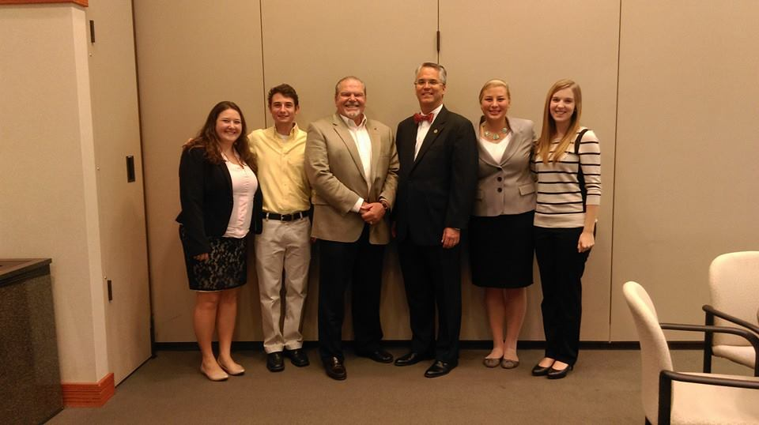

**2015-2016 Newsletter Staff**



Bridgewater SHRM 2015 Officers!

BC

**SHRM Nation is on the Rise!**

If you have a newsletter-worthy story or suggestion. Email us at dle006.

Have a safe and fantastic Thanksgiving break!

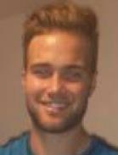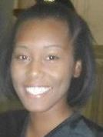

**President**

**Historian**

**Treasurer**



**Secretary**

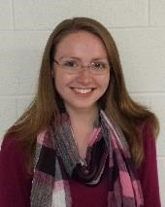

**Vice President**

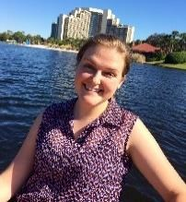

Forrest Turner Katie Rexrode Sarah Herndon Logan Fazakerley Desiree Elliott

2015-2016 ● Volume 2, Issue 1 ● BC SHRM Newsletter

Page 1 of 1