Values, Evangelicals, and Vote Choice
Vote choice in a United States’ presidential election is both a simple process and a complex process. Vote choice is not concerned with whether or not an individual decides to vote; rather, it describes for which candidate the individual decides to vote. It can be a simple process as the voter can simply rely on heuristics such as political party labels to choose a candidate, but it can also be a complex process because a variety of factors, such as political ideology, positions on policy issues, basic personal values, and religion, all influence vote choice as well as political party identification and each other. Normally, these factors come into alignment which allows an individual to vote for a candidate that does not conflict with their beliefs and identifications.
The 2016 Presidential Election provided a particularly interesting example of the complexities and simplicities of vote choice. Presidential Candidate Donald Trump ran under the Republican Party label, espousing a political ideology that was sometimes contradictory and not always the traditional conservative Republican ideology. Campaigning in a populist style, Trump championed the group of middle-Americans who had been left behind both economically and socially and pitted them against the traditional political establishment represented by Democratic Candidate Hillary Clinton. Throughout the campaign cycle, some evangelical leaders and congregational members enthusiastically endorsed and threw their support behind Trump. This support may illustrate the simplicities of vote choice—voters vote for the candidate from the party with which they have always identified. However, other Evangelical identifiers were slower to endorse and support Trump, viewing him as a slightly lesser evil than Hillary Clinton. His sometimes derogatory and offensive statements as well as his scandalous and flamboyant lifestyle conflicted with some evangelicals’ morals, personal values, and religious beliefs. However, many of them still ultimately supported Trump in the general election, demonstrating the complexities of vote choice. In order to better understand this complex relationship and the effect of Evangelical Christianity on the 2016 Presidential Election, I devised the research question “To what degree was the vote choice of evangelical Christians influenced by their basic personal values?” Investigating the impact evangelicals’ basic personal values have on identities such as political party identification and political ideology identification will help to uncover the role these values play in shaping political opinions and behavior. Consequently, this may shed some light on why evangelicals supported and voted for Donald Trump at such high rates.
Literature Review
The literature surrounding vote choice and the multiple variables that influence why individuals vote the way they do is extensive. Most of the literature is limited in the sense that it focuses primarily on political ideology, political party identification, demographics, and policy issues. While these variables hold significant value for understanding vote choice, they do not strike at the heart of what compels individuals to vote for a particular candidate—why they identify with one party over another or why they hold the ideology they do. Schwartz’s value theory seems to hold possibilities for uncovering what motivates all aspects of an individual’s political behavior. Schwartz and other scholars utilizing his theory have made connections between basic personal values and political behavior, but the strength and direction of this relationship is unclear. A review of the literature begins with a discussion of voting behavior, then Schwartz’s value theory, moving to an examination of political party identification and political ideology, then demographics, and ending with a review of evangelicalism and religion’s interaction with values.

Voting Behavior
When thinking about how individuals decide who to vote for, one might assume that individuals would weigh candidates’ positions on issue or examine the candidates’ political ideologies. Elites in society may do this, but large portions of the general population do not (Niemi & Weisberg, 1976). One may also assume that members of the public can be placed on the dimension regarding controversial policy issues that have caused intense political debate among elites for many years. Once again, this is not the case (Niemi & Weisberg, 1976). Editors Richard Niemi and Herbert Weisberg, in their book Controversies in Voting Behavior, show that large portions of the public “simply do not belong on the dimension at all” (Niemi & Weisberg, 1976, p. 93). Therefore, they should not be included in that policy’s particular issue public—the group of individuals who have an active stake in the particular policy. Because the political effects of a controversy are only felt among the members of an issue public, the mass public fragments into a multitude of smaller, more specific issue publics (Niemi & Weisberg, 1976). Individuals within these groups have formed strong opinions and positions regarding the issue and may vote based upon these positions. Within the general population as a whole, issue beliefs tend to fluctuate over time (Niemi & Weisberg, 1976).
In addition to not having positions on most policy issues, members of the mass public do not have a set ideological position (Niemi & Weisberg, 1976). The authors state that the mass public does not even think in ideological terms as they are defined by political scientists (Niemi & Weisberg, 1976). The general public seems to combine and constrain ideas in different ways than do the elites (Niemi & Weisberg, 1976). Consequently, members of the mass public experience a lack of constraint even when they are informed on the issues that are highly controversial at that time (Niemi & Weisberg, 1976). This means that even if an individual holds an extremely conservative position on one particular issue, one could not necessarily expect him to hold extremely conservative positions on all or even most other issues. Although the general public shows an ideological lack of constraint along with unstable issue positions, beliefs about political parties remain remarkably stable over time (Niemi & Weisberg, 1976). This indicates that an individual’s political party identification may be the primary factor in the individual’s voting behavior.
Values
In order to understand more about how an individual arrives at their policy preferences and political ideology, one must analyze the individual’s basic personal values. Researchers have attempted to describe the relationships between values and political beliefs and attitudes, but there is still little evidence clarifying the strength and direction of the relationships (Feldman, 2003). Shalom H. Schwartz provided a summary of Values Theory in his work “Basic Human Values: An Overview,” in which he defines values as the goals individuals prioritize in their lives and which serve as the individuals’ guiding principles (Schwartz S. , 2005). Schwartz originally identified 57 different values, which he included in his Schwartz Value Survey (SVS). The SVS asked individuals to rate the importance of the values in their lives.
Using the SVS in his 1992 study, Schwartz analyzed the value structures of groups of teachers and groups of students in twenty countries. By plotting the responses to his survey, Schwartz was able to construct a diagram very similar to Diagram 1: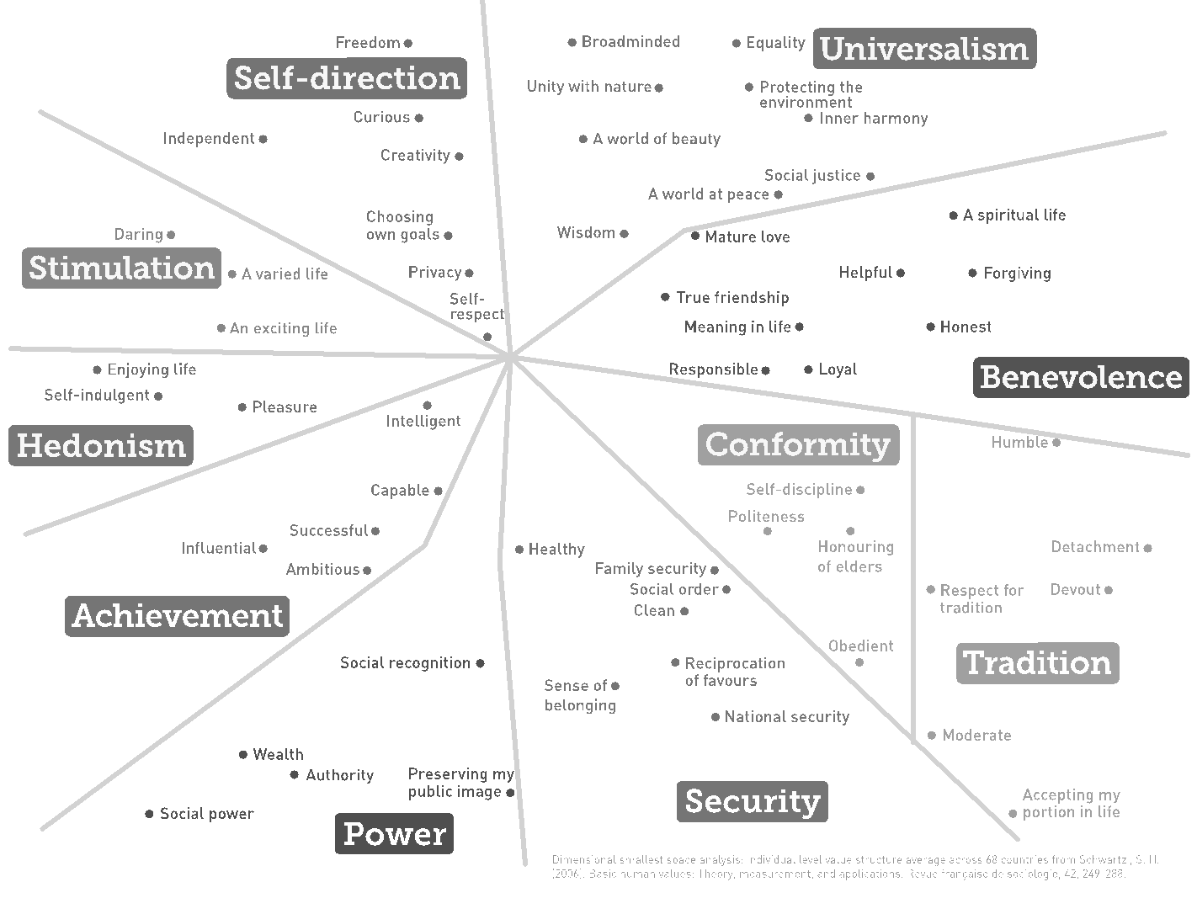 Further analysis of the diagram and the survey responses resulted in Schwartz identifying ten distinct motivational value types or basic personal values that appeared consistently throughout the SVS responses (Schwartz & Berkowitz, 1992). The defining feature main aspect of each value is the goal or motivation that it expresses (Schwartz & Berkowitz, 1992). Each of the ten basic personal values is listed below along with a brief description of its central motivating goal:
Diagram 1
Diagram 1
- Self-Direction: Independent thought and action; choosing, creating, exploring.
- Stimulation: Excitement, novelty, and challenge in life.
- Hedonism: Pleasure and sensuous gratification for oneself.
- Achievement: Personal success through demonstrating competence according to social standards.
- Power: Social status and prestige, control or dominance over people and resources.
- Security: Safety, harmony, and stability of society, of relationships, and of self.
- Conformity: Restraint of actions, inclinations, and impulses likely to upset or harm others and violate social expectations or norms.
- Tradition: Respect, commitment, and acceptance of the customs and ideas that traditional culture or religion provide the self.
- Benevolence: Preserving and enhancing the welfare of those with whom one is in frequent personal contact.
- Universalism: Understanding, appreciation, tolerance, and protection for the welfare of all people and for nature.
Some of these values clearly have close relationships, such as achievement and power (Schwartz S. , 2005, p. 3). If an individual values achievement, they may be drawn to positions of power as a way to fulfill their achievement desires. While some values have close relationships, other values are opposed to each other, such as universalism is opposed to power (Schwartz S. , 2005, p. 3). Therefore, as Schwartz states, “action taken in the pursuit of each value type have psychological, practical, and social consequences that may be compatible or may conflict with the pursuit of other value types” (Schwartz & Berkowitz, 1992, p. 4). For example, if an individual values universalism, they will be unlikely to value power as well because power focuses on the individual over others. If an individual values conformity, their actions are likely to conflict with the value of self-direction.
The ten basic motivational values that Schwartz identified appeared universally across all cultures, and their relationships with each other manifested in a consistent manner across all cultures as well. Schwartz represented these relationships with the following chart: 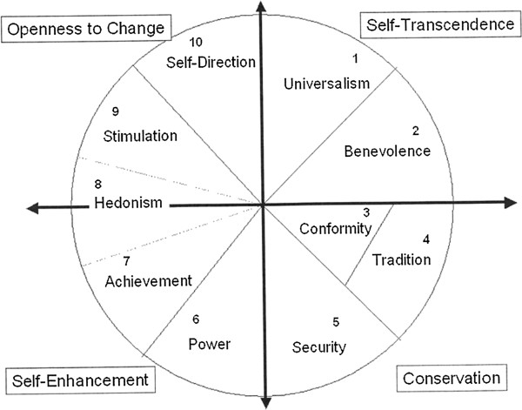
Diagram 2
(Buuri & Maercker, 2014)
Diagram 2
(Buuri & Maercker, 2014)
The motivational values fall into a circular continuum: the closer any two values are to each other in either direction, the more similar are their motivations (Schwartz & Berkowitz, 1992). Because the values are on a continuum rather than in discreet, inflexible categories, the exact locations of the partition lines between the motivational value categories are essentially arbitrary (Schwartz & Berkowitz, 1992). A specific value found near the border of two motivational value type categories in Diagram 1 will reflect a combination of the motivational goals attributed to the values types on either side of the partition line in Diagram 2 (Schwartz & Berkowitz, 1992). For example, within the universalism value region, the specific value of social justice is located near the border with benevolence, while the value of wisdom is located near the border with self-direction. This most likely shows that social justice is concerned for the welfare of both all human kind and those close to an individual (benevolence), while wisdom shares motivation with self-direction’s reliance on one’s own thoughts and actions (Schwartz & Berkowitz, 1992). In his 2012 work, An Overview of the Schwartz Theory of Basic Values, Schwartz describes the nature of the continuum by noting the shared motivations of adjacent value types:
- “Power and achievement--social superiority and esteem;
- Achievement and hedonism--self-centered satisfaction;
- Hedonism and stimulation--a desire for affectively pleasant arousal;
- Stimulation and self-direction--intrinsic interest in novelty and mastery;
- Self-direction and universalism--reliance upon one's own judgment and comfort with the diversity of existence;
- Universalism and benevolence--enhancement of others and transcendence of selfish interests;
- Benevolence and tradition--devotion to one's in-group;
- Benevolence and conformity--normative behavior that promotes close relationships;
- Conformity and tradition--subordination of self in favor of socially imposed expectations;
- Tradition and security--preserving existing social arrangements that give certainty to life;
- Conformity and security--protection of order and harmony in relations;
- Security and power--avoiding or overcoming threats by controlling relationships and resources.” (Schwartz S. H., 2012)
Schwartz’s value theory assumes that only motivational value types that are adjacent to each other in the circular continuum can blend together because they share similar motivational goals. However, a study by Sonia Roccas et al. found blending in the middle of the circular continuum between motivational values in nonadjacent regions when she examined the Big Five personality trait conscientiousness. Conscientiousness correlated highly with both achievement and conformity—two values that are usually orthogonal in the motivational circle (Roccas et al., 2002). This example of values blending across the circular continuum raises the possibility that other values may blend together in unknown and unanticipated ways (Roccas et al., 2002).
Analyzing the circular motivational continuum, Schwartz identified two main relationships represented by two diagonal axes. The first axis, beginning at the self-direction and stimulation values and ending at the security, conformity, and tradition values, represents the dimension that Schwartz labels “openness to change vs. conservation” (Schwartz S. , 2005). The second axis, beginning at the universalism and benevolence values and ending at the power and achievement values, represents the “self-enhancement vs. self-transcendence” dimension (Schwartz S. , 2005). Schwartz analyzes how these dimensions and their related values can impact policy views such as gay marriage. He found that between the statement “gays should be free to live as they like” and the ten values, conformity and tradition correlated most negatively to freedom for gays—most likely because heterosexual marriage has been the cornerstone of society for centuries and any changes to it could be viewed as a threat to society (Schwartz S. , 2005, p. 4). Meanwhile hedonism and universalism correlated most positively with freedom for gays—most likely due to hedonism’s focus on personal pleasure and universalism’s focus on tolerance and the welfare of all (Schwartz S. , 2005). This relationship demonstrates the “openness to change vs. conservation” dimension on the motivational continuum. While Schwartz analyzes how these two dimensions and their related values impact policy views such as gay marriage, he does not examine their impact on political ideology in his theory overview.
Value Theory: Values and Politics
Whereas Schwartz in his 2005 work only described his value theory, author Stanley Feldman added political implications while supporting Schwartz’s value theory in Values, Ideology, and the Structure of Political Attitudes (Feldman, 2003). Analyzing Schwartz’s 1994 work, Feldman discusses the two axes that Schwartz discovered: openness to change vs. conservatism and self-transcendence vs. self-enhancement. Feldman notes that Schwartz related the first axis to classical liberalism, or “whether government should devote more to guarding and cultivating individual freedoms and civil rights or to protecting the societal status quo by controlling deviance from within or enemies from without” (Feldman, 2003, p. 494). This dimension shows the conflict between the government protecting individual rights and freedoms (openness-to-change values) or protecting social customs and traditions (conservation values). The second axis, representing the dimension of economic egalitarianism, “refers to whether government should devote itself more to promoting equality by redistributing resources or to protecting citizens’ ability to retain the wealth they generate in order to foster economic growth and efficiency” (Feldman, 2003, p. 494). This dimension shows the conflict between an unfettered free market and capital accumulation (self-enhancement values) on one hand and a system of wealth redistribution and social justice on the other hand (self-transcendence values).
Feldman adds that this two-dimensional structure in Schwartz’s diagram of the ten basic values would be useful for thinking about conflicts in society, both in the political and social spheres of life (Feldman, 2003). Also, Feldman notes that slight shifts in an individual’s orientation in Schwartz’s two dimensional representation could create different political beliefs and ideologies (Feldman, 2003). Thus, a change in an individual’s values could drastically alter their political ideology. For example, if an individual valued tradition they would very likely be a conservative on the political ideology spectrum. However, if their views shifted so that they valued stimulation over tradition, their political ideology would likely also shift from conservative to liberal. More research is needed to uncover the relationships between basic personal values and political dispositions.
In their 2013 study of fifteen different countries, Shalom Schwartz et al. produced results that supported Schwartz’s earlier discovery of the conservation vs. openness-to-change dimension and the self-transcendence vs. self-enhancement dimension (Schwartz et al, 2013). Focusing on basic personal values, the study analyzed how these values affect core political values. Schwartz et al defined basic personal values as “cognitive representations of individuals’ broad goals that apply across specific situations,” and core political values as “overarching normative principles and belief assumptions about government, citizenship, and society” (Schwartz et al, 2017, p. 902-903). The study showed that the structure of motivations that organizes the basic personal values also organizes the core political values, which implies that core political values are simply public expressions of basic personal values in the political realm (Schwartz et al, 2017). Unfortunately, Schwartz’s examination of this relationship is limited, and it is not currently clear whether basic personal values or core political values form first. While core political values are expressions of basic personal values, basic personal values could also be derivatives of core political values. It is likely, however, that both directions of causality are present in the relationship between basic personal values and core political values. More research is needed to examine this relationship more closely.
While Schwartz et al established that basic personal values and core political values are inherently intertwined, a study by authors Goren, Schoen, Reifler, Scotto, and Chittick examines the relationship between basic personal values and political attitudes. The authors note that political values and issues are not synonymous; rather, a political value will be closely related to the policy option it explains (Goren et al., 2016). For example, the political value of the morality of warfare is closely related to the policy option of the use of military power (Goren et al., 2016). The study found that in the United States, basic personal values do drive policy opinion formulation, but not all basic personal values are consequential or relevant to the formulation of opinions (Goren et al., 2016). This could indicate that certain values take precedence over other values within an individual. The values of self-transcendence and conservation drive public opinion formulation, while self-enhancement and openness-to-change do not have nearly as much of an effect (Goren, Schoen, Reifler, Scotto, & Chittick, 2016). This is an understandable trend because conservation values focus on social stability, obedience, and devoutness, while self-transcendence values focus on social justice, equality, and helpfulness. The foci of the conservation and self-transcendence values manifest themselves routinely in public opinion in the form of policy areas such as welfare and law-and-order, indicating that “public opinion in the United States depends on beliefs about the good and just society to a much greater extent than beliefs about the virtue of private gain” (Goren, Schoen, Reifler, Scotto, & Chittick, 2016, p. 24).
Shalom Schwartz concluded in his 1992 study that there were no more universal motivational value types to be found. He wrote, “Hence, pending evidence to the contrary, the 10 value types here may be taken as tentatively exhausting the distinctive, near universal, motivational types of values” (Schwartz & Berkowitz, 1992, p. 37). Although individual cultures or geographic regions may have some of their own distinct motivational values, the ten listed in his study are the only ones that could be applied universally. However, Schwartz did acknowledge that future research could uncover new universal motivational value types that his study had failed to identify. In order to fit the definition of “universal” as laid out by Schwartz, a value would have to be found in at least 90% of all countries.
Political Party Identification and Political Ideology
Due to the fact that political party identification serves an important role in voting behavior, researchers have tried to determine what draws an individual to a particular political party. Authors David O. Sears and Sheri Levy discuss the sources of political party identification in Childhood and Adult Political Development. They state that “party identification turns out to be by far the strongest and most consistent prediction of Americans’ voting preferences, and seems to have been so for over a century” (Sears & Levy, 2003, p. 76). Sears and Levy outline three particular time periods in an individual’s life that show distinct party identification trends: childhood, early adulthood, and adulthood (Sears & Levy, 2003). In childhood, the greatest source of party identification by far is the parents (Sears & Levy, 2003). Parental transmission of their own party identification is “substantial,” although it is not perfect (Sears & Levy, 2003). In early adulthood, however, the party identification transmitted by the parents begins to weaken as the child’s own views and policy preferences begin to play a larger role in shaping their party identification (Sears & Levy, 2003). After early adulthood, when the child has reached full adulthood and identifies with a particular party, party identification does not weaken (Sears & Levy, 2003). This means that the events one experiences and the ideas one is exposed to during young adulthood can create long-lasting beliefs and attitudes within the individual that could cause them to identify with a particular political party for the remainder of their life. Interestingly, economic issues and other issues of self-interest in adulthood show little statistical evidence of changing an individual’s sociopolitical attitudes and party identification (Sears & Levy, 2003).
Sears and Levy also address how “the times”—current political events, sociocultural changes, and economic conditions—can result in the “generational effect” in which age cohorts share “powerful experiences that will mark them as distinctive for life” (Sears & Levy, 2003, pp. 84-85). For example, American youth in the 1960’s were subject to “left-liberal” political and social events (Sears & Levy, 2003, p. 85). Since then, the “left-liberal distinctiveness” has persisted among this age cohort, not just among those who engaged in the protests, but also those who merely passively observed them (Sears & Levy, 2003, p. 85). Consequently, as this age cohort has grown older, it has remained reliably more liberal than older or younger age cohorts. This generational effect stands in opposition to the life cycle effects which state that conservatism correlates positively with age. Evidence shows that the elderly from the pre-New Deal age cohort tilted toward the Republican Party, while the elderly from the New Deal age cohort favored the Democratic Party, thus resembling the generational effect (Sears & Levy, 2003). Additionally, party identification strength increases with age (Sears & Levy, 2003). Due to the fact that generational effects exist and that party identification strength increases as individuals age, one could expect voters who developed left-liberal leanings in their youth as a result of socio-political events to support the Democratic Party at increasing rates as they age.
Whereas Sears and Levy seem to view changes in political party identification in the electorate as the result of significant sociopolitical events or economic conditions affecting the identification within an age cohort, Alan Abramowitz and Kyle Saunders posit that “dramatic changes in the distribution of party loyalties over the course of several election cycles” can occur not as the result of a “cataclysmic precipitating event,” but as the result of changes in the parties’ issue stances (Abramowitz & Saunders, 1998, p. 648). Increased ideological differences between the Democratic Party and Republican Party in the Reagan and post-Reagan eras drove the policy stances of the two parties further apart (Abramowitz & Saunders, 1998, pp. 636-637). This increased distance between the policy stances of the Democratic Party and Republican Party made it easier for voters to recognize the differences between the policy stances of the two parties (Abramowitz & Saunders, 1998).
Consequently, voters have been choosing the party they identify with based upon their own individual policy preferences, not based upon the political party identification transmitted to them by their parents (Abramowitz & Saunders, 1998, p. 647). The authors show that conservatives raised by Democratic parents abandoned their parents’ party and switched to the GOP (Abramowitz & Saunders, 1998, p. 645). For liberals raised by Republican parents, 54% preferred the Democratic Party, while only 39% stayed with the GOP (Abramowitz & Saunders, 1998, p. 646). This shows that contrary to Sears and Levy’s articulation, party identification can change in adulthood without a major precipitating event if the parties’ ideologies and policy stances move further apart. Therefore, individuals’ ideologies and policy preferences are necessary factors in order for them to identify with a political party.
While Abramowitz and Saunders examine changes in party identification and political ideology within and between different age cohorts, authors Bardes and Oldendick discuss the trends in both political party identification and political ideology within the United States as a whole from 1972 to 2012. Although party identification in the U.S. can be volatile, it has shown some relatively stable trends (Bardes & Oldendick, 2017). The number of individuals who identify as either Democrats or Republicans has declined over the course of the last sixty years—Democrats fell from 49% to 33% and Republicans fell from 28% to 22%--while the number of individuals who identify as Independents has risen to more than 40% of the electorate (Bardes & Oldendick, 2017). Under traditional definitions of partisanship, Independents may lean towards one party or another, but they do not actively identify with one. However, researcher Jack Dennis found that among the electorate, roughly 16.4% of individuals will identify as independents while still supporting one party over the other (1988). These individuals are still party supporters but they prefer to identify as Independents. Consequently, they are referred to as “closet partisans” (Dennis, 1988). One may think that this change in political party identification may be indicative of changes in political ideologies, but the overall trend for political ideology identification remained fairly stable from 1972 to 2012 (Bardes & Oldendick, 2017). Roughly 25% of individuals self-identify as liberal, 40% as conservative, and 33% as moderate (Bardes & Oldendick, 2017). Liberals tend to identify with the Democratic Party, and Conservatives tend to identify with the Republican Party, while the Democratic Party enjoys the identification advantage (Bardes & Oldendick, 2017). This means that liberals identify as Democrats at a higher rate than conservatives identify as Republicans. The authors do not address why the identification advantage exists for the Democratic Party and why conservatives identify as Republicans at lower rates. Forty percent of the electorate identifies as conservative but only twenty-two percent identify as Republicans. Future research should focus on why this identification gap is so high for conservatives and the Republican Party.
Demographics: Religion
Party identification’s measurement and stability have been embroiled in debate at the aggregate level. At the individual level, however, there are demographic groups that predictably identify as either Republicans or Democrats (Jackson & Carsey, 2002). In their study Group Effects on Party Identification and Party Coalitions across the United States, authors Robert Jackson and Thomas Carsey examine the political party identification trends of demographic groups. The authors identify three broad cleavages that divide American politics today. First, cleavages from the New Deal era manifest today in the form of economic interests. Second, different attitudes toward race, stemming from the legacy of slavery and historical attitudes towards African-Americans, provide another cleavage line. Third, new, modern cleavages exist around ideological and value-based differences which often results in differences in lifestyles. As the authors note, due to the diversity of electoral coalitions, “…it is simply not possible to describe in one or two sentences the nature of party cleavage in the United States. Any effort that attempts to do so is demonstrably reductionist” (Jackson & Carsey, 2002, p. 84).
The authors identify three main demographics that most reliably predict political party identification: race, gender, and income. African-Americans, women, and low-income individuals provide the base of support for the Democratic Party, while whites, men, and higher income people tend to support the Republican Party. Across the country, the three types of cleavages appear in different geographical regions. In the South, the racial cleavage is most apparent as African Americans comprise the largest group of net supporters for the Democrats, but it is not the only cleavage at play in the South. Women and poor individuals are also large blocks of support for the Democratic Party in the South. In addition to race, gender, and income, Jackson and Carsey highlight the influence of religion in party identification. Protestants generally support the Republican Party, and Catholics and secularists tend to support the Democratic Party (Jackson & Carsey, 2002).
Religion as a demographic is unique because it is more a product of personal choice than other demographics are. Researchers David Leege and Michael Welch examine the impact of religion and other demographics on political orientation in their article, Religious Roots of Political Orientation Variations among American Catholic Parishioners. Leege and Welch focus on the role of foundational religious beliefs in shaping political ideology. Foundational beliefs “may involve symbols learned through religious institutions, but they are also operating beliefs that interpret and give meaning to the reality perceived by the individual” (Leege & Welch, 1989, p. 140). Previous scholars have asserted that religion is a system of symbols that address the ultimate ills of humanity, procedures and doctrines to alleviate these ills, and loyalty to organizations that promote the procedures and doctrines. However, the reality that an individual’s religion addresses may not be the reality the individual actually experiences. In order to deal with the disjunctive realities, individuals turn to foundational religious beliefs. Foundational religious beliefs allow individuals to understand what is problematic in the world, find ways to deal with or avoid the problems, and possibly give solutions for the problems (Leege & Welch, 1989). Seeing as how foundational religious beliefs can shape an individual’s perspective and guide his choices, it seems that they could fall under the various categories in Schwartz’s basic personal value theory.
Leege and Welch’s study concluded that religious beliefs do provide a foundation for, or at least influence, political orientations. Since foundational religious beliefs shed light on political values that are attitudinal in character, the spectrum of individualistic and communitarian beliefs serves as a strong predictor of political liberalism or conservatism within an individual. Additionally, foundational religious beliefs can predict basic political values. Different foundational religious beliefs lead to predictable differences in political ideology as well as political policy positions. While foundational religious beliefs predict more of an individual’s positions in the private sphere than in most public policy issues, the ongoing shift of public policy from the economic sector to the cultural sector may result in foundational religious beliefs becoming even more useful in predictor public policy positions. (Leege & Welch, 1989).
In terms of public policy issues, most Americans view the country as being split along moral-cultural lines as a result of different religious preferences. This viewpoint resulted in the perception of a “culture war” in American society. In Chapter 7 of their book, Religion and Politics in the United States, authors Kenneth Wald and Allison Calhoun-Brown discuss the opinions of members of different major religions regarding economic liberalism, moral-cultural issues, social justice, and foreign policy. Conservative religious traditions such as evangelical Protestantism, Mormonism, and Islam tend to hold more conservative policy positions, particularly in economics and social justice areas, but large minorities of these groups hold liberal views. Interestingly, religious liberals are more concerned with social justice issues, while religious conservatives are more concerned with sexual-morality questions (p. 187). This seems to be indicative of the influential role basic personal values and core political values play in forming individuals’ policy preferences
Evangelicalism
The 2016 Presidential Election saw an increased focus on the American Evangelical Christian population and its political support for Republican candidate Donald Trump. Scholars differ in their exact definitions of what it means to be an Evangelical Christian, but regardless of the differentiating minutiae of definitions, scholars agree on four central aspects of what defines an evangelical: the bible, the cross, conversion, and activism. Some authors, such as Randall Balmer in his book Evangelicalism in America, combine the cross and conversion into one aspect. However, separating the cross and conversion into two different defining aspects allows for greater understanding of evangelical beliefs. First, evangelicals believe in the divine and inerrant nature of the Bible. This often resulted in a literal interpretation and a direct application to daily lives of Scriptures (Balmer, 2016, p. xi). As the American Free Methodists’ newspaper announced in 1884, “There is but one final standard of Christian living, or Christian doctrine. That standard is the Word of God, revealed to man in the Holy Scriptures” (Free Methodist, 1884, p. 1). Consequently, evangelical theology is rooted directly in Biblical text and is intellectually constrained to the Scriptures (Bebbington, 2005).
Second, evangelicals are defined by their belief in salvation by the cross. According to the evangelical interpretation of the Bible, the sacrifice of Jesus Christ on the cross was the act that bought humanity’s salvation (Bebbington, 2005). Evangelical theology emphasizes that the sinful nature of humanity that would damn mankind to hell created an imperative need for redemption and reconciliation to God. This reconciliation to God took place through the process of substitutionary atonement: Jesus Christ, the Son of God, was sacrificed on the cross in humanity’s place as its representative so that believers in Jesus’ sacrifice might be forgiven (Bebbington, 2005). Crucial to this belief was the doctrine of incarnation: the belief that Jesus was the physical manifestation of God (Bebbington, 2005). Following the example of the Apostle Paul, evangelicals placed extreme emphasis on the cross as the means by which souls received salvation for their sins (Bebbington, 2005). Evangelicals differed from other groups of Christians such as Catholics by not placing emphasis on the physical details of the crucifixion—the nails, the crown of thorns, or the crucifix—but on the “spiritual power of Christ the redeemer” to make the believer “born again” (Bebbington, 2005, p. 29).
The third defining aspect of evangelicalism is conversion. Conversion is considered to be the human side of the process of salvation in which the individual has to deliberately turn away from sin, or repent, and trust in Jesus Christ as their personal Savior through faith (Bebbington, 2005). A theological term for this process is justification by faith: God sees a sinner surrender to him and acquits the sinner of their sin (Bebbington, 2005). This leads to the divine side of conversion known as regeneration: the process of the God regenerating the sinner’s soul (Bebbington, 2005). Conversion is a highly personal process, often born out of an individual’s sense of despair. Those who go through the process of conversion are often referred to as having been “born again” (Bebbington, 2005, p. 32). The term “born again” comes from John Chapter 3 in the Bible in which Jesus speaks to a member of the Jewish ruling council named Nicodemus:
^{“3} Jesus replied, “Very truly I tell you, no one can see the kingdom of God unless they are born again.”
⁴ “How can someone be born when they are old?” Nicodemus asked. “Surely they cannot enter a second time into their mother’s womb to be born!”
⁵ Jesus answered, “Very truly I tell you, no one can enter the kingdom of God unless they are born of water and the Spirit. ⁶ Flesh gives birth to flesh, but the Spirit gives birth to spirit. ⁷ You should not be surprised at my saying, ‘You must be born again… ¹⁶ For God so loved the world that he gave his one and only Son, that whoever believes in him shall not perish but have eternal life.”
Thus, the term “born again” does not refer to a physical rebirth, but rather to a spiritual rebirth. A person is considered to be born again once they believe in Jesus’ sacrifice and believe that Jesus is their personal Savior who has taken away their sins.
The fourth and final defining aspect of evangelicalism is activism. Evangelicalism is marked by an eagerness to be doing things in order to spread the Gospel to non-Christian people (Bebbington, 2005). This process is known as evangelism—the namesake of the evangelical movement (Balmer, 2016). As the main American Baptist newspaper announced in 1868, “It is the duty of every one who knows the good news of salvation through Christ to tell the good news, as he has opportunity and ability, to his companion who does not know it, that he too may be saved” (Examiner and Chronicle, 1868). This idea comes from the Great Commission in the Bible in which Jesus, just prior to His ascension to heaven, directed His followers to go out into the world and spread the news about Him (Balmer, 2016). Today, instead of going on missions trips themselves, many evangelicals will support missionaries who go out into the world and spread the Gospel for them (Balmer, 2016).
Brian Steensland’s and Eric Wright’s work, American Evangelicals and Conservative Politics: Past, Present, and Future examines the political identification and activity of Evangelicals. While the influence of evangelicalism in American politics first came to light with the rise of the moral majority and Ronald Reagan, evangelicals’ identification with conservativism and the Republican actually began in the post-World War II era, particularly in accord with anti-communism and in response to the moral decadence of the 1960’s (Steensland & Wright, 2014). In 1942, the creation of the National Association of Evangelicals marked a “middle course between the political disengagement of fundamentalism and the cultural accommodation of mainline Protestantism” (Steensland & Wright, 2014, p. 706). The authors show that Evangelicals hold more conservative views on social issues, but their positions on economic issues are not quite as conservative. The Republican Party, however, serves to combine economic conservativism with the social conservativism to which evangelicals are already more predisposed (Steensland & Wright, 2014). Evangelicals do not identify exclusively with the Republican Party, but most are much more likely to vote Republican than Democratic—especially in a presidential election (Steensland & Wright, 2014).
While fundamentalists and non-fundamentalist disagree on some doctrinal issues, they also have different views regarding political beliefs and activism. A 1988 study by Corwin Smidt titled Evangelicals within Contemporary American Politics: Differentiating between Fundamentalist and Non-Fundamentalist Evangelicals sought to uncover the exact political differences between the two groups of evangelicals. Smidt found that:
“The data indicate that, after the introduction of the control variables, fundamentalist evangelicals tend to be more likely than non-fundamentalist evangelicals to classify themselves as political conservatives, to adopt more conservative positions on political issues, to express greater salience for their religion politically, to be politically active, and to be more Democratic in their partisanship” (Smidt, 1988, pp. 616-617).
The fact that Smidt found that fundamentalist evangelicals tend to be more Democratic in their political party identification is particularly curious since the majority of evangelicals today identify as Republicans. This finding could be a result of the time at which Smidt conducted his study. Evangelicals’ support for George H.W. Bush in 1988 and the moral questionability of Bill Clinton both before he was in office and while he was in office could have moved evangelicals more solidly into the Republican camp. Regarding the evangelicals today who do identify as Democrats, it is currently unknown whether they are fundamentalist or non-fundamentalist evangelicals. More research is needed to answer this question.
Although traditional doctrine holds that evangelicals should avoid politics, evangelicals became increasingly politically active during the 1970’s, largely as a result of Jimmy Carter, the first openly evangelical presidential candidate in more than fifty years (Wilcox, 1988). The Carter candidacy mobilized evangelical political support as no campaign ever had before, resulting in large numbers of both fundamentalist and evangelical Christians voting for Carter in the 1976 election (Wilcox, 1988). Carter’s candidacy also helped break down evangelicals’ beliefs that they were not supposed to engage in politics as Carter openly argued that Christians were morally obligated to participate (Wilcox, 1988). In the later years of the 1970’s, Christian activists formed the Christian Voice and the Moral Majority—two groups that would serve as the foundation for the New Christian Right that would help propel Ronald Reagan to the White House in 1980 and 1984 (Wilcox, 1988).
Regarding the escalation of religion in presidential campaigns, Phillip Hammond made several observations. First, he supported Wilcox’s finding that the 1976 Carter campaign brought religion into an American presidential campaign to a degree that had not been present in decades. Hammond adds that religion was present in the 1984 presidential election to a greater degree than the 1980 presidential election which had a greater emphasis on religion than the 1976 campaign (Hammond, 1985). Second, he notes that Reagan’s support among Christians in 1984 came mainly from the “‘moderately’ Christian rightist” rather than the strongly conservative or fundamentalist Christians (Hammond, 1985, p. 189). This observation is in line with Smidt’s finding that fundamentalists tended to be more conservative but also more Democratic than other evangelicals. Hammond also states that being a member of the Christian right is not equivalent to being a Republican supporter. As he writes, “certain fundamentalist views are so fundamental…that, unless politicians are ‘correct’ on those, their [evangelicals’] other views are largely irrelevant to voting choice” (Hammond, 1985, p. 189). So, if a politician is not “correct” on a certain fundamentalist view that a fundamentalist holds very closely, that politician will very likely not get the fundamentalist’s vote. For example, if the moral questions surrounding abortion make abortion the most important issue to a fundamentalist, they may be unwilling to support a candidate they otherwise might support if the candidate supports abortion rights.
Religion and Values
Interestingly, Schwartz’s 1992 study hypothesized that spirituality would be an eleventh value in addition to the ten basic motivational values (Schwartz & Berkowitz, 1992). Spirituality is concerned with answering the questions of ultimate meaning in the universal, the meaninglessness of reality, and the existential crisis, while traditions and religion often serve as the mechanisms that allow people to do so (Schwartz & Berkowitz, 1992). Spirituality values would express the motivations of meaning and inner harmony achieved from transcending the concerns of everyday reality (Schwartz & Berkowitz, 1992). However, the search for meaning and coherence is a sophisticated process in which the average person does not engage routinely or even at all (Schwartz & Berkowitz, 1992). Consequently, instead of turning to spirituality values, individuals use other values such as tradition, security, and conformity to find coherence and meaning (Schwartz & Berkowitz, 1992).
While Schwartz’s and Berkowitz’s hypothesis that individuals use other values in lieu of spirituality is a logical conclusion, it would seem that most people do not think about ultimate meaning and the existential crisis on a routine basis. Therefore, they would not need religion to answer questions related to those topics. However, the prominence of various religions across the globe and throughout different societies and cultures shows that religion still serves some purpose within the individual—most likely allowing the individual to conform to society, participate in traditions, and feel secure. Future research could focus on to what extent religion provides access to the basic motivational values. The placement of the SVS value a spiritual life within the motivational continuum can show the varied nature of spirituality between different people and different cultures. For example, in Schwartz and Sagiv’s study “Identifying Culture-Specifics in the Content and Structure of Values,” a spiritual life appeared most frequently in either the benevolence, universalism, or tradition regions of the continuum (Schwartz & Sagiv, 1995). All three of these regions signify a transcendence of material self-interests for different reasons. Benevolence transcends the self for the welfare of close others, universalism for the welfare of all others, and tradition for the demands of a higher authority (Schwartz & Sagiv, 1995). In samples of Muslim and Catholic teachers, a spiritual life appeared most frequently in the traditions region, signifying these two groups’ association of spirituality with a super-natural authority.
An individual’s value system as well as their religion clearly impact their political ideology, party identification, issue positions, and vote choice. However, it is unclear what the strength and direction of the relationship between values and religion are. In her 2005 study, Sonia Roccas found that “both directions of causality between religion and values are very likely” (p. 757). The cross-cultural study found that people with different levels of religiosity have different value priorities. Individuals who are more religious “attribute relatively high importance to values that express the motivation to avoid uncertainty, and relatively low importance to values that express the motivations to follow one’s sensuous, hedonistic desires, and the motivation to be independent in thought and action” (Roccas, 2005). While Roccas’ study does outline the relationships between values and religiosity, it does not uncover what the value priorities of specific religious groups such as evangelical Christians may be.
During the summer of 2019, I conducted a research project to uncover evangelicals’ identification levels with the different motivational values. The study surveyed evangelicals Christians and measured the level of identification they held for each value. The results show that evangelicals identify most with Benevolence, Security, and Self-direction and least with Power, Achievement, and Hedonism. While my study was limited, it did at least provide some preliminary results and data. Further study of evangelicals and their values may help to uncover the motivations behind their political dispositions and behavior.
Clearly, basic personal values are an important component of an individual’s personal identity. They influence political values as well as political attitudes which then influences specific political ideology and public policy positions. As authors Bardes and Oldendick found, political ideology directly affects party identification which Sears and Levy established was the most reliable predictor of vote choice. Therefore, it appears that basic personal values and vote choice are intrinsically related. More research is needed into whether basic personal values or core political values develop first although the order of develop would not necessarily affect vote choice. However, while values are important in forming political ideology and policy positions, they are not the only factors that contribute to the formation these things. Demographics also have an impact on policy positions and political ideology with a particularly large influence coming from religion.
Evangelicals’ support for Donald Trump conflicts with religious doctrine and the values inherent in the Christian faith. Trump’s derogatory statements toward immigrants, women, and other social groups as well as his ostentatious and scandalous personal life are directly at odds with the teachings of Christ-like love in Christianity and the values of Benevolence and Universalism that are present in the Christian faith. However, as Trump ran as the Republican Party candidate as a self-proclaimed conservative, evangelicals would have been cross-pressured in their support for Trump and his moral failings. Despite this cross-pressure and the cognitive dissonance that evangelical Trump supporters theoretically would have experienced, these voters overwhelmingly threw their electoral support behind the Republican candidate.
Two plausible explanations exist for this apparent contradiction. First, it is possible that within the evangelical voters who supported Donald Trump, their already-existent Republican Party identification and conservative political ideology identification would have allowed them to overlook Trump’s obvious adverse rhetoric and personal life. If this is the case, this would show that evangelicals simply rely on basic heuristics such as political party identification to guide their vote choice instead of engaging in deeper self-reflection of their religious values and basic personal values. Second, it is also possible that certain values expressed by the Trump campaign resonated strongly with evangelical voters, superseding religious values and doctrines. This would imply that the average evangelical voter is capable of examining and knowing their own personal values and comparing them to both their religious values and the values expressed by the Trump campaign. After examining and comparing values, any disagreements between the two would have to overcome party and ideological identifications. This level of introspection being able to overcome such strong identities seems highly unlikely from the average voter, so the first explanation appears to be the most reasonable.

Hypothesis
In a study of evangelical Christians’ vote choice in the 2016 election, basic personal values will increase evangelicals’ identification with the Republican Party and conservative ideology, causing them to be more likely to vote for Donald Trump.
Research Design
There are three main ways to measure an individual’s values. The first of these is the Schwartz Value Survey (SVS). Used in Schwartz’s foundational 1992 work, “Universals in the Content and Structure of Values: Theoretical Advances and Empirical Tests in 20 Countries,” the SVS asks a respondent to rate the importance they would assign to 57 different value items as life-guiding principles using a 9-point scale (Lindeman & Verkasalo, 2005). Examples of the different values include equality, inner harmony, social power, and a spiritual life. A full list of the different values in included in Appendix A. The second way to measure values is with the Short Schwartz Value Survey (SSVS). In the shortened form, respondents are presented with the name of each of the ten motivational value types—universalism, benevolence, conservativism, tradition, security, power, achievement, hedonism, stimulation, and self-direction—along with its value items. For example, a participant would be asked to rate the importance as a life-guiding principle such as “Power, that is, social power, authority, and wealth” (Lindeman & Verkasalo, 2005). Responses in this survey type are also rated on a 9-point scale as they are in the SVS. Lindeman and Verkasalo, in their study “Measuring Values With the Short Schwartz Value Survey” found that the spatial structure of value relationships created using the SSVS showed “high similarity” with the structure obtained by the SVS. Therefore, the SVSS and the SVS are both effective methods for identifying individuals’ identification with values as they produce results that are nearly identical.
While both the SVS and the SVSS require respondents to rate their value priorities, the third measuring technique—the Portrait Values Questionnaire (PVQ)—does not. Instead, the PVQ provides the respondent with a “short verbal portrait” of different people and asks the respondent how much the person in the portrait is like them (Schwartz, Melech, & Lehmann, 2001). Responses are ranked on a 6-point scale: very much like me, like me, somewhat like me, a little like me, not like me, and not like me at all (Schwartz, Melech, & Lehmann, Extending the Cross-Cultural Validity of the Theory of Basic Human Values with A Different Method of Measurement, 2001). Each verbal portrait describes a person’s goals or motivations without stating a specific value, but the portrait is designed to reflect a specific value (Schwartz, Melech, & Lehmann, 2001). For example, a PVQ survey question measuring the security value would be written as follows: “It is important to someone to live in secure surroundings. They avoid anything that might endanger their safety.” This type of question measures the value identification without directly mentioning the specific value. Schwartz et al. found that the PVQ and the SVS yield very similar measurements of the ten values (Schwartz, Melech, & Lehmann, 2001). While the PVQ measures values indirectly, it is not as intellectually challenging as the SVS can be (Schwartz, Melech, & Lehmann, 2001). Therefore, it is an ideal survey type to use with less educated or intellectually mature respondents. This conclusion is predicated on the findings of Niemi and Weisberg who found that members of the mass public do not hold consistent views on nearly anything, and as such, would have considerable difficulty analyzing their own levels of identification with multiple values in the manner that the SVS and SSVS would ask them to do.
The survey we created featured thirty questions from the PVQ as well as other questions relating to things such as demographics, political party identification, political ideology, and Donald Trump job approval. Appendix B provides a full copy of the survey used in this study. Each of the ten motivational value types was measured by three separate questions with answers to each question measured on a 5-point scale. The scale measurements are as follows: 1=not like me at all, 2=somewhat unlike me, 3=neither like nor unlike me, 4=somewhat like me, 5=very much like me.
We distributed the survey through the online survey company Survey Monkey. Researchers Nicos Antoniades and Perry Haan showed in their work, Government capabilities as drivers of performance: path to prosperity, that SurveyMonkey is an effective tool for gathering political opinions (2019). The process of using SurveyMonkey consisted of me transforming the survey questions into question on the SurveyMonkey website. We then purchased as many responses as our budget would allow us to afford. One flaw with the survey is its limited scope. It was limited in the number of respondents we were allowed to have due to our budget. It was also limited to a certain number of question; our membership package capped our survey at fifty questions. If we had been able to include more questions in the survey our data would have been much more comprehensive and allowed us to engage in a deeper analysis of the variables.
Once an individual began the survey, the first question asked them if they identified as an Evangelical Christian, Born Again Christian, or both. Respondents could choose from the answers Yes, No, or Not Sure. Those who answered “Yes” were able to continue with the rest of the survey, while those who did not answer “Yes” were unable to continue with the remaining survey questions. This allowed us to survey our target population—self-identifying evangelical or born again Christians. Those who self-identified as Evangelical, Born Again, or Both continued with the survey and encountered questions measuring a variety of factors. While the survey measured things such as policy positions regarding a couple of specific policy areas and presidential approval, the bulk of the survey focused on gathering data measuring six main variable categories: vote choice, political ideology, political party identification, religiosity, demographics, and motivational value type identification.
Variables
The main variable under consideration in this study is the dependent variable, trump_or_other_vote. This is a dichotomous variable with the two options being Donald Trump or votes for any other candidates. Measured by the survey question, “Which candidate did you vote for in the 2016 Presidential Election?” the possible answers were Donald Trump, Hillary Clinton, Other, or Did not vote. Recoding the variable consisted of combining the Clinton and Other answers into one category and changing Did not vote to system missing in order to create the dichotomous variable. Due to the fact that Donald Trump won the 2016 election, votes for Trump were coded as 1, while vote for all other candidates were coded as 0.
Multiple independent variables were under consideration in this study. The first set of independent variables included all variables included in the survey that measured demographics. The first of these, age_ten_years, is a recoded variable that condensed all typed age responses into six categories of roughly ten year age increments. The categories are coded as 1=18-29, 2=30-39, 3=40-49, 4=50-59, 5=60-69, and 6=70-79. The second demographic variable, gender, asked respondents to mark their gender. Male respondents were coded as 1, female respondents as 2, and respondents who preferred not to answer as 3. The next variable, race, asked individuals which race they identified as. Responses were coded as follows: 1=White, 2=African-American, 3=Hispanic, 4=Native American, 5=Asian, 6=Multiracial, 7=Biracial, 8=other. The fourth independent variable in the demographic set was education, as measure of the highest level of education a respondent had attained. Responses were coded as follows: 1=No high school, 2=high school graduate/GED, 3=some college, 4=two year college degree, 5=four year college degree, 6=postgraduate.
The second set of independent variables included the political party identification and political ideology identification variables. The first of these variables, party_ID, measured with which political party an individual identified. Democrat identifiers were coded as 1, Republicans as 2, Independents as 3, and any other party identifications as 4. The survey also measured the strength of the Republican and Democrat identifications while asking Independent identifiers which political party they leaned towards more. The second independent variable was political_ideology, a measure of an individual’s political ideology. Liberal identifiers were coded as 1, moderate identifiers as 2, conservative identifiers as 3, and those who were not sure of their ideology as 4. This variable also measured the strength of liberal and conservative identifications while asking moderates which ideology they leaned towards more.
The third set of independent variables included all the variables that measured a respondent’s identification with basic personal values. Within the survey, each value was measured by three separate questions. The questions answers were measured on a 5-point scale from “1=Not at all like me” to “5=Very much like me.” In order to analyze the ten motivational value types more effectively, I created an additive index for each value type by adding up the answers to the three questions that corresponded to a specific value. These ten different additive indexes became the main variables under analysis. Within each index, the highest possible value was fifteen, while the lowest possible value was three. In order to determine whether respondents exhibited high or low levels of identification, we determined that a value of nine would serve as an average multiplying the middle value of three by the three questions that were included in a given value index. Basic personal value scale variables were named as follows: Universalism (universalism_scale), Benevolence (benevolence_scale), Conservativism (conservativism_scale), Tradition (tradition_scale), Security (security_scale), Power (power_scale), Achievement (achievement_scale), Hedonism (hedonism_scale), Stimulation (stimulation_scale), Self-Direction (selfdirection_scale)
The fourth set of independent variables consisted of two variables measuring the religiosity of Evangelical, Born Again, or Both identifiers. The first of these variables, literal_biblical_interpretation, asked respondents if they believed in a literal interpretation of the Bible. Those who responded “Yes” were coded as 1, while those who responded “No” were coded as 0. The next variable in this set, church_attendence, measured how often the respondent attended a religious service. Responses were measured and coded on a 7-point scale as follows: 1=Never or Less Than Once A Year, 2=Once A Year, 3=Several Times A Year, 4=Once A Month, 5=2-3 Times A Month, 6=Nearly Every Week, and 7=Every Week or more.
The fifth set of independent variables included those measuring individuals’ support of different means of assisting the poor. The first variable, govt_assistance, measured individuals’ responses when asked if the government was doing too little, too much, or just the right amount in assisting the poor. Responses were coded as 1=Too Little, 2=Just the Right Amount, and 3=Too Much. The second variable, community_support, measured individuals’ responses when asked if community organizations such as churches and charities were doing too little, too much, or just the right amount in assisting the poor. Responses were coded as 1=Too Little, 2=Just the Right Amount, and 3=Too Much.
In order to study the effect that each independent variable has on the dichotomous dependent variable, I determined that multiple regression would be the most appropriate method of measurement. In his work Ideology and Vote Choice in the 2004 Election, author William Jacoby showed that a simple logistical regression is a powerful tool for understanding why people vote the way they do in a presidential election when only one independent variable is being analyzed (2008). However, since my study contains multiple independent variables, logistical regression is not the appropriate tool to use. Instead, a multiple regression analysis would be the appropriate tool to use for this particular study. As Alan Zuckerman et al showed in their study, A Structural Theory of Vote Choice: Social and Political Networks and Electoral Flows in Britain and the United States, multiple regression analysis can be extremely effective in analyzing the effects that multiple independent variables have on the dichotomous dependent variable (1994).
Analysis
The analysis began with a binary logistic regression with trump_vs_other_vote as the dependent variable and the first block of independent variables, the respondents’ demographics.
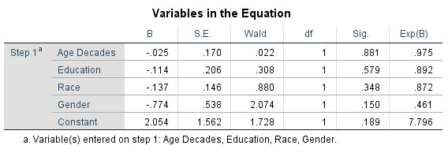
None of the demographic independent variables in the first block had a statistically significant relationship with the dependent variable. The next block of independent variables added to the regression table included party_ID and political_ideology.
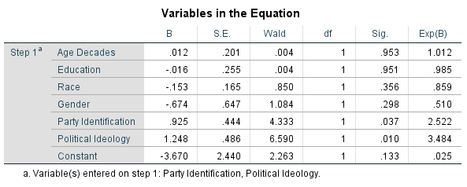
Both of these newly-added variables have a statistically-significant positive relationship with voting for Trump. As an individual moves one step along the party identification scale, they become 92.5% more likely to have voted for Donald Trump in 2016 according the B value; this is significant at the 0.037 level. As an individual moves one step along the political ideology identification scale, they become 124.8% more likely to have voted for Trump; this is significant at the 0.010 level. Next, adding the ten values scale independent variables in the third block produced the following regression table:

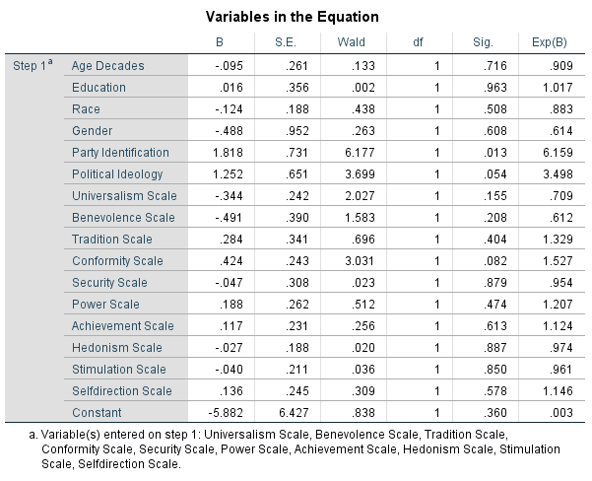
Among the newly-added value variables, none held a statistically significant relationship with trump_vs_other_vote. The value closest to being significant was the Conformity Scale with a significance value of 0.082. Interestingly, with the addition of the values variables, political party identification became more statistically significant with a value of 0.013, while political ideology identification became just barely statistically insignificant with a value of 0.054. After the values scales, I added the fourth block of independent variables—the religiosity variables.
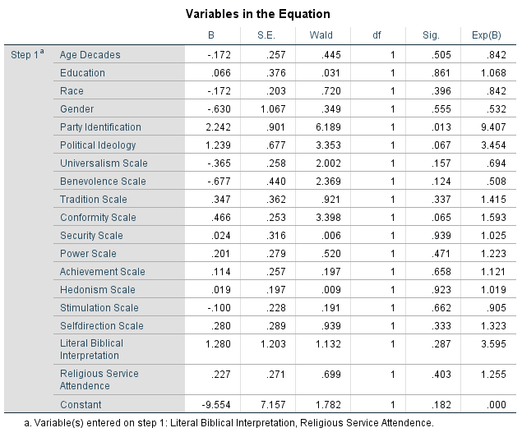
While neither of the religiosity variables was statistically significant, they did affect the significance of two notable values. First, political ideology identification became even more insignificant, moving from 0.054 to 0.067. Second, the conformity scale independent variable’s significance value decreased to 0.065 making conformity more significant. Additionally, while political party identification’s significance value remained the same, its B value increased to 2.242 indicating that party identification played a huge role in whether or not an individual decided to vote for Donald Trump. I next added the fifth and final block of independent variables—those measuring support for assistance to the poor.
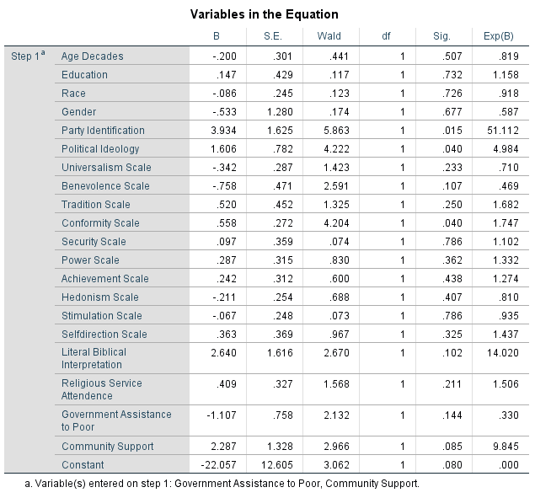
With the inclusion of these two variables, there are some notable relationships. First, while neither of the newly-added variables was statistically significant, Community Support was close at the 0.085 significance level. The Conformity Value scale variable finally reached a significant level at 0.040 with B value of 0.558. So, with every increase in an individual’s identification with the conformity value, they would be 55.8% more likely to have voted for Donald Trump in 2016. Political ideology identification was also significant at the 0.040 level, but its B value was substantially higher at 1.606. Perhaps most importantly, however, political party identification remained statistically significant with a value of 0.015 and a B value 3.934.
Discussion
The results of the analysis reveal several important trends that impact the understanding of vote choice within the United States’ evangelical Christian population. First and foremost, political party identification seems to be far and away the most reliable predictor of evangelicals’ vote choice. This agrees with authors Sears and Levy’s findings in their 2003 work in which they found that party identification was the most reliable and consistent predictor of vote choice. Throughout the regression tables, the effect of party identification only grew—its B value never decreased and its statistical significance stayed very high. This relationship contrasts with political ideology identification’s relationship with vote choice. The regression tables show that the B value for political ideology remained relatively the same, while the statistical significance oscillated between significant and insignificant. Since political ideology’s relationship with vote choice did not match party identification’s relationship with vote choice, it seems to be that for at least some evangelicals, party identification is not necessarily predicated upon political ideology. This seems to agree with Niemi and Weisberg’s claims that the American electorate has a lack of intellectual sophistication regarding their ideology and, therefore, must rely on heuristics, such as political party identification, that political elites supply to them.
While it may be the case that many evangelical voters simply rely on heuristics such as political party identification when casting votes, it appears that basic personal values are not completely without significance. In the regression tables, one variable in particular—the Conformity Scale—showed that basic personal values could reach a statistically significant level in their relationship with vote choice once other variables were factored into the equation. Regarding conformity, once the religiosity variables were factored in, its statistical significance increased from 0.082 to 0.065. While this is not yet a statistically significant level, it did reach the significant level of 0.040 once the assistance for the poor variables were included. Government Assistance to the Poor’s negative relationship with voting for Trump and Community Support’s positive relationship with voting for Trump increased Conformity Scale’s statistical significance although neither one was significant in itself. While conformity was the only basic personal value that reached statistical significance in the regression table, benevolence slowly increased in significance, and other independent variables that could be added might push benevolence’s value to a statistically significant level.
Evangelicals’ high levels of identification with the Republican Party seems to be the defining variable that could explain their support for Donald Trump in 2016. Additionally, the political conservativism with which most evangelicals identify further predicted their support for Trump. While it seemed as if evangelicals’ basic personal values might have swayed them away from supporting Trump, the analysis shows that the only value that reached a level of statistical significance in evangelicals’ vote choice was conformity—a value that would lead them to being more politically conservative, more likely to support candidates who appealed to the past, and more likely to conform to the political views of their evangelical friends and family. Trump postured himself as a political conservative throughout his campaign and constantly appealed to the past through his rhetoric and his slogan “Make America Great Again.” Consequently, the hypothesis was supported, if only through the value of conformity. Although none of the values were the predominant factor in predicting evangelicals’ vote choice, they may strengthen evangelicals’ party identification and political ideology.
In the future, additional research is needed to reveal how influential values are for forming these political identities. More research is needed to find the mechanism by which Trump’s campaign expressed the identifications evangelicals hold. Clearly, the Republican identification was expressed by Trump running under the Republican Party’s banner. Other identifications such as basic personal value identifications and policy positions were expressed by the Trump campaign and transmitted to evangelicals in a less direct manner. Future research could analyze Trump’s language in his statements—both official and unofficial—to determine to what degree evangelicals might identify with them. Any additional studies ideally should collect more responses from evangelicals as this project’s dataset was limited in its number of respondents. Whatever future research finds, it is sure to impact our understanding of why evangelical Christians could vote for Donald Trump, a candidate who seemingly contradicts all evangelical beliefs and values.

References
(1868, January 2). Examiner and Chronicle.
(1884, January 9). Free Methodist, p. 1.
(1895, October 1). Life & Light , p. 6.
Abramowitz, A. I., & Saunders, K. L. (1998). Ideological Realignment in the U.S. Electorate. The Journal of Politics, 634-652.
Antoniades, N., & Haan, P. (2019). Government capabilities as drivers of performance: path to prosperity. Heliyon.
Balmer, R. (2016). Evangelicalism in America. Waco: Baylor University Press.
Bardes, B., & Oldendick, R. W. (2017). Public Opinion: Measuring the American Mind. London, UK: Rowman & Littlefield.
Bebbington, D. (2005). The Dominance of Evangelicalism. Downers Grove: InterVarsity Press.
Buuri, A., & Maercker, A. (2014). Differences in prevalence rates of PTSD in various European countries explained by war exposure, other trauma and cultural value orientation. BMC Research Notes.
Dennis, J. (1988). Political Independence in America, Part I: On Being an Independent Partisan Supporter. British Journal of Political Science, 77-109.
Feldman, S. (2003). Values, Ideology, and the Structure of Political Attitudes. In L. Huddy, R. Jervis, & D. Sears, Oxford Handbook of Political Psychology. New York: Oxford University Press.
Goren, P., Schoen, H., Reifler, J., Scotto, T., & Chittick, W. (2016). A unified theory of value-based reasoning and U.S. public opinion. Political Behavior.
Hammond, P. E. (1985). Evangelical Politics: Generalizations and Implications. Review of Religious Research, 189-192.
Jackson, R. A., & Carsey, T. M. (2002). Group Effects on Party Identification and Party Coalitions across the United States. American Politics Research.
Jacoby, W. (2008). Ideology and Vote Choice in the 2004 Election.
Leege, D. C., & Welch, M. R. (1989). Religious Roots of Political Orientations: Variations Among American Catholic Parishioners. The Journal of Politics, 137-162.
Lindeman, M., & Verkasalo, M. (2005). Measuring Values With the Short Schwartz Value Survey. Journal of Personality Assessment, 170-178.
Niemi, R. G., & Weisberg, H. F. (1976). Controversies in American Voting Behavior. United States: W. H. Freeman and Company.
Roccas, S. (2005). Religion and Value Systems. Journal of Social Issues, 747-759.
Schwartz, S. (2005). Basic Human Values: An Overview.
Schwartz, S. H. (2012). An Overview of the Schwartz Theory of Basic Values. Online Readings in Psychology and Culture.
Schwartz, S. H., & Berkowitz, L. (1992). Universals in the Content and Structure of Values: Theoretical Advances and Empirical Tests in 20 Countries. Advances in experimental social psychology, 1-65.
Schwartz, S. H., & Sagiv, L. (1995). Identifying Culture-Specifics in the Content and Structure of Values. Journal of Cross-Cultural Psychology, 92-116.
Schwartz, S. H., Melech, G., & Lehmann, A. (2001). Extending the Cross-Cultural Validity of the Theory of Basic Human Values with A Different Method of Measurement. Journal of Cross-Cultural Psychology, 519-542.
Sears, D., & Levy, S. (2003). Oxford Handbook of Political Psychology. New York: Oxford University Press.
Smidt, C. (1988). Evangelicals within Contemporary American Politics: Differentiating between Fundamentalist and Non-Fundamentalist Evangelicals. The WEstern Political Quarterly, 601-620.
Steensland, B., & Wright, E. (2014). American Evangelicals and Conservative Politics: Past, Present, and Futuree. Sociology Compass, 705-717.
Wald, K., & Calhoun-Brown, A. (2018). Religion and Politics in the United States. London: Rowman and Littlefield.
Wilcox, C. (1988). The Christian Right in Twentieth Century America: Continuity and Change. The Review of Politics, 659-681.
Zuckerman, A., Valentino, N., & Zuckerman, E. (1994). A Structural Theory of Vote Choice: Social and Politial Networks and Electoral Flows in Britain and the United States. The Journal of Politics, 1008-1033.

