Religion and Vote Choice in the 2016 Presidential Election
Vote choice in a United States’ presidential election is both a simple process and a complex process. Vote choice is not whether or not an individual decides to vote; rather, it is for which candidate the individual decides to vote. It is a simple process because the voter can simply rely on heuristics such as political party labels to choose a candidate, but it is also a complex process because a variety of factors, such as political ideology, positions on policy issues, basic personal values, and religion, all influence each other, political party identification and vote choice. Normally, these factors come into alignment to lead an individual to vote for a candidate that does not conflict with him or his beliefs and identifications.
The 2016 Presidential Election provided a particularly interesting example of the complexities and simplicities of vote choice. Presidential Candidate Donald Trump ran under the Republican Party label espousing a political ideology that was sometimes contradictory and not always the traditional conservative Republican ideology. Trump campaigned in a populist style as he championed the group of middle-Americans who had been left behind economically and socially and pitted them against the traditional political establishment represented by Hillary Clinton. Throughout the campaign cycle, some Evangelical leaders, congregations, and individuals enthusiastically endorsed and threw their support behind Trump. This support could be an illustration of the simplicities of vote choice—voters vote for the candidate from the party with which they have always identified. However, other Evangelical identifiers were slower to endorse and support Trump, viewing him as a slightly lesser evil than Hillary Clinton. His sometimes derogatory and offensive statements as well as is scandalous life and flamboyant lifestyle conflicted with some Evangelicals’ morals, personal values, and religious beliefs. However, many of them still ultimately supported Trump in the general election, demonstrating the complexities of vote choice. In order to better understand this complex relationship and the effect of Evangelical Christianity on the 2016 Presidential Election, I devised the research question “To what degree did Evangelical Christianity impact vote choice in the 2016 presidential election?”
Literature Review
In order to understand how voters choose between different candidates, one must understand how party identification, political ideology, value systems, and demographics such as religion impact individuals. None of these things can be looked at as the sole cause of vote choice; rather, vote choice is the product of all four of these broad categories interacting with and influencing one another within the individual. A variety of literature exists on these various topics, but the literature rarely or never examines the relationship between all four. First, it shows how political party identification forms and changes over time. Second, the literature shows how political ideology can impact party identification. Third, value systems impact individuals’ political ideology, but the literature does not show they impact political party identification. Finally, demographics, particularly religion, impact party identification and political ideology, but not much literature examines the relationship between religion and value systems.
Voting Behavior
When thinking about how individuals decide who to vote for, one might assume that individuals would weigh candidates’ positions on issue or examine the candidates’ political ideologies. Elites in society may do this, but large portions of the general population do not (Niemi & Weisberg, 1976). One may also assume that members of the public can be placed on the dimension regarding controversial policy issues that have caused intense political debate among elites for many years. Once again, this is not the case (Niemi & Weisberg, 1976). Authors Richard Niemi and Herbert Weisberg, in their book Controversies in Voting Behavior, show that large portions of the public “simply do not belong on the dimension at all” (Niemi & Weisberg, 1976, p. 93). Therefore, they should not be included in that policy’s particular issue public—the group of individuals who have an active stake in the particular policy. Because the political effects of a controversy are only felt among the members of an issue public, the mass public fragments into a multitude of smaller, more specific issue publics (Niemi & Weisberg, 1976). Individuals within these groups have formed strong opinions and positions regarding the issue and may vote based upon these positions. Within the general population as a whole, issue beliefs tend to fluctuate over time (Niemi & Weisberg, 1976).
In addition to not having positions on most policy issues, members of the mass public do not have a set ideological position (Niemi & Weisberg, 1976). The authors state that the mass public does not even think in ideological terms as they are defined by political scientists (Niemi & Weisberg, 1976). The general public seems to combine and constrain ideas in different ways than do the elites (Niemi & Weisberg, 1976). Consequently, members of the mass public experience a lack of constraint even when they are informed on the issues that are highly controversial at that time (Niemi & Weisberg, 1976). This means that even if an individual holds an extremely conservative position on one particular issue, one could not necessarily expect him to hold extremely conservative positions on all or even most other issues. Although the general public shows an ideological lack of constraint along with unstable issue positions, beliefs about political parties remain remarkably stable over time (Niemi & Weisberg, 1976). This indicates that an individual’s political party identification may be the primary factor in the individual’s voting behavior.
Political Party Identification and Political Ideology
Due to the fact that political party identification serves an important role in voting behavior, researches have tried to determine what draws an individual to a particular political party. Authors David O. Sears and Sheri Levy discuss the sources of political party identification in Chapter Three of the Oxford Handbook of Political Psychology. They state that “party identification turns out to be by far the strongest and most consistent prediction of Americans’ voting preferences, and seems to have been so for over a century” (Sears, 2003, p. 76). Sear and Levy outline three particular time periods in an individual’s life that show distinct party identification trends: childhood, early adulthood, and adulthood (Sears, 2003). In childhood, the greatest source of party identification by far is the parents (Sears, 2003). Parental transmission of their own party identification is “substantial,” although it is not perfect (Sears, 2003). In early adulthood, however, the party identification transmitted by the parents begins to weaken as the child’s own views and policy preferences begin to play a larger role in shaping their party identification (Sears, 2003). After early adulthood, when the child has reached full adulthood, party identification does not decline any further (Sears, 2003). Interestingly, economic issues and other issues of self-interest in adulthood show little statistical evidence of changing an individual’s sociopolitical attitudes and party identification (Sears, 2003). Sears and Levy address how “the times”—current political events, sociocultural changes, and economic conditions—can result in the “generational effect” in which age cohorts share “powerful experiences that will mark them as distinctive for life” (Sears, 2003, pp. 84-85). For example, American youth in the 1960’s were subject to “left-liberal” political and social events (Sears, 2003, p. 85). Since then, the “left-liberal distinctiveness” has persisted among this age cohort, not just among those who engaged in the protests, but also those who merely passively observed them (Sears, 2003, p. 85). Consequently, as this age cohort has grown older, it has remained reliably more liberal than older or younger age cohorts. This generational effect stands in opposition to the life cycle effects which state that conservatism correlates positively with age. Evidence shows that the elderly from the pre-New Deal age cohort tilted toward the Republican Party, while the elderly from the New Deal age cohort favored the Democratic Party, thus resembling the generational effect (Sears, 2003). Additionally, party identification strength increases with age (Sears, 2003). Due to the fact that generational effects exist and that party identification strength increases as individuals age, one could expect voters who developed left-liberal leanings in their youth as a result of socio-political events to support the Democratic Party at increasing rates as they age.
Whereas Sears and Levy seem to view changes in political party identification in the electorate as the result of significant sociopolitical events or economic conditions affecting the identification within an age cohort, Alan Abramowitz and Kyle Saunders posit that “dramatic changes in the distribution of party loyalties over the course of several election cycles” can occur not as the result of a “cataclysmic precipitating event,” but as the result of changes in the parties’ issue stances (Abramowitz & Saunders, 1998, p. 648). Increased ideological differences between the Democratic Party and Republican Party in the Reagan and post-Reagan eras drove the policy stances of the two parties further apart (Abramowitz & Saunders, 1998, pp. 636-637). This increased distance between the policy stances of the Democratic Party and Republican Party made it easier for voters to recognize the differences between the policy stances of the two parties (Abramowitz & Saunders, 1998). Consequently, voters have been choosing the party they identify with based upon their own individual policy preferences, not based upon the political party identification transmitted to them by their parents (Abramowitz & Saunders, 1998, p. 647). The authors show that conservatives raised by Democratic parents abandoned their parents’ party and switched to the GOP (Abramowitz & Saunders, 1998, p. 645). For liberals raised by Republican parents, 54% preferred the Democratic Party, while only 39% stayed with the GOP (Abramowitz & Saunders, 1998, p. 646). This shows that contrary to Sears and Levy’s articulation, party identification can change in adulthood without a major precipitating event if the parties’ ideologies and policy stances move further apart. Therefore, individuals’ ideologies and policy preferences are necessary factors in order for them to identify with a political party.
While Abramowitz and Saunders examine changes in party identification and political ideology within and between different age cohorts, authors Bardes and Oldendick discuss the trends in both political party identification and political ideology within the United States as a whole from 1972 to 2012. Although party identification in the U.S. can be volatile, it has shown some relatively stable trends from (Bardes & Oldendick, 2017). The number of individuals who identify as either Democrats or Republicans has declined over the course of the last sixty years—Democrats fell from 49% to 33% and Republicans fell from 28% to 22%--while the number of individuals who identify as Independents has risen to more than 40% of the electorate (Bardes & Oldendick, 2017). Independents may lean towards one party or another, but they do not actively identify with one. One may think that this change in political party identification may be indicative of changes in political ideologies, but the overall trend for political ideology identification remained fairly stable from 1972 to 2012 (Bardes & Oldendick, 2017). Roughly 25% of individuals self-identify as liberal, 40% as conservative, and 33% as moderate (Bardes & Oldendick, 2017). Liberals tend to identify with the Democratic Party, and Conservatives tend to identify with the Republican Party, while the Democratic Party enjoys the identification advantage (Bardes & Oldendick, 2017). This means that liberals identify as Democrats at a higher rate than conservatives identify as Republicans. The authors do not address why the identification advantage exists for the Democratic Party and why conservatives identify as Republicans at lower rates. Forty percent of the electorate identifies as conservative but only twenty-two percent identify as Republicans. Future research should focus on why this identification gap is so high for conservatives and the Republican Party.
Values
In order to understand more about how an individual arrives at his policy preferences and political ideology, one must analyze the individual’s basic personal values. Researchers have attempted to describe the relationships between values and political beliefs and attitudes, but there is still little evidence clarifying the strength and direction of the relationships (Huddy, Jervis, & Sears, 2003). Shalom H. Schwartz provided a summary of Values Theory in his work “Basic Human Values: An Overview” (Schwartz, 2005). Values are the goals individuals prioritize in their lives and which serve as the individuals’ guiding principles (Schwartz, 2005). Schwartz derives ten values from the three elements that are necessary for the human condition: biological needs, requisites for social interaction, and group needs (Schwartz, 2005). The ten basic values are listed below along with a brief description of its central motivating goal:
- Self-Direction: Independent thought and action; choosing, creating, exploring.
- Stimulation: Excitement, novelty, and challenge in life.
- Hedonism: Pleasure and sensuous gratification for oneself.
- Achievement: Personal success through demonstrating competence according to social standards.
- Power: Social status and prestige, control or dominance over people and resources.
- Security: Safety, harmony, and stability of society, of relationships, and of self.
- Conformity: Restraint of actions, inclinations, and impulses likely to upset or harm others and violate social expectations or norms.
- Tradition: Respect, commitment, and acceptance of the customs and ideas that traditional culture or religion provide the self.
- Benevolence: Preserving and enhancing the welfare of those with whom one is in frequent personal contact.
- Universalism: Understanding, appreciation, tolerance, and protection for the welfare of all people and for nature.
Some of these values clearly have close relationships, such as achievement and power (Schwartz, 2005, p. 3). If an individual values achievement, he or she may be drawn to positions of power as a way to fulfill his or her achievement desires. While some values have close relationships, other values are opposed to each other, such as universalism is opposed to power (Schwartz, 2005, p. 3). If an individual values universalism, he will be unlikely to value power as well, because power focuses on the individual over others. Schwartz contrived a chart to represent the relationship between the ten distinct values.

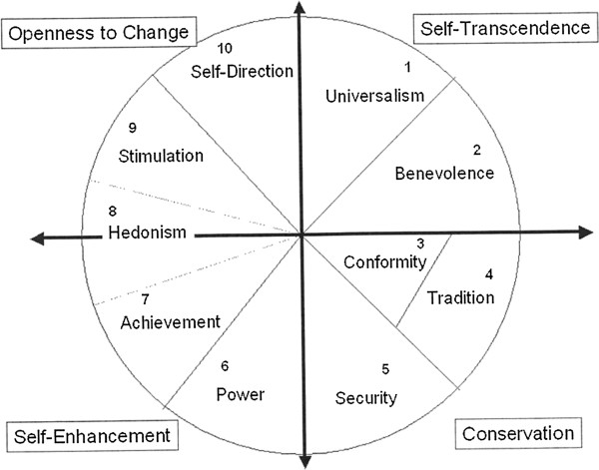
(Buuri & Maercker, 2014))

The closer any two values are to each other in either direction, the more similar are their motivations (Schwartz, 2005). Analyzing the diagram, Schwartz identified two main relationships which he identified by drawing two axes diagonally across the diagram. The first axis, beginning at the self-direction and stimulation values and ending at the security, conformity, and tradition values, represents the dimension that Schwartz labels “openness to change vs. conservation” (Schwartz, 2005). The second axis, beginning at the universalism and benevolence values and ending at the power and achievement values, represents the “self-enhancement vs. self-transcendence” dimension (Schwartz, 2005). While Schwartz analyzes how these dimensions and their related values impact policy views such as gay marriage, he does not discuss their impact on political ideology in this overview of his theory.
Whereas Schwartz in his 2005 work only described his value theory, author Stanley Feldman added political implications while supporting Schwartz’s value theory in Chapter 14 of the Oxford Handbook of Political Psychology (Huddy, Jervis, & Sears, 2003). Analyzing Schwartz’s 1994 work, Feldman discusses the two axes that Schwartz discovered: openness to change vs. conservatism and self-transcendence vs. self enhancement. Feldman notes that Schwartz related the first axis to classical liberalism, or “whether government should devote more to guarding and cultivating individual freedoms and civil rights or to protecting the societal status quo by controlling deviance from within or enemies from without” (Huddy, Jervis, & Sears, 2003, p. 494). The second axis, representing the dimension of economic egalitarianism, “refers to whether government should devote itself more to promoting equality by redistributing resources or to protecting citizens’ ability to retain the wealth they generate in order to foster economic growth and efficiency” (Huddy, Jervis, & Sears, 2003, p. 494). Feldman adds that this two-dimensional structure in Schwartz’s diagram of the ten basic values would be useful for thinking about conflicts in society, both in the political and social spheres of life (Huddy, Jervis, & Sears, 2003). Also, Feldman notes that slight shifts in an individual’s orientation in Schwartz’s two dimensional representation could create different political beliefs and ideologies (Huddy, Jervis, & Sears, 2003). Thus, a change in an individual’s values could drastically alter his or her political ideology. For example, if an individual valued tradition he would very likely be a conservative on the political ideology spectrum. However, if his views shifted so that he valued stimulation over tradition, his political ideology would likely also shift from conservative to liberal.
In their 2013 study of fifteen different countries, Shalom Schwartz et al. produced results that supported Schwartz’s earlier findings of conservation being opposed to openness and self-transcendence being opposed to self-enhancement (Schwartz et al, 2013). Focusing on basic personal values, the study analyzed how these values affect core political values. Schwartz et al defined basic personal values as “cognitive representations of individuals’ broad goals that apply across specific situations,” and core political values as “overarching normative principles and belief assumptions about government, citizenship, and society” (Schwartz et al, 2017, p. 902-903). The study showed that the structure of motivations that organizes the basic personal values also organizes the core political values (Schwartz et al, 2017). Therefore, it is apparent that core political values are simply public expressions of basic personal values in the political realm (Schwartz et al, 2017). Unfortunately, it is not currently clear whether basic personal values or core political values form first. While core political values are expressions of basic personal values, basic personal values could also be derivatives of core political values. More research is needed to examine this relationship more closely.
While Schwartz et al established that basic personal values and core political values are inherently intertwined, a study by authors Goren, Schoen, Reifler, Scotto, and Chittick examines the relationship between basic personal values and political attitudes. The authors note that political values and issues are not synonymous; rather, a political value will be closely related to the policy option it explains (Goren, Schoen, Reifler, Scotto, & Chittick, 2016). For example, the political value of the morality of warfare is closely related to the policy option of the use of military power (Goren, Schoen, Reifler, Scotto, & Chittick, 2016). The study found that in the United States, basic personal values do drive policy opinion formulation (Goren, Schoen, Reifler, Scotto, & Chittick, 2016). However, not all basic personal values are consequential or relevant to the formulation of opinions (Goren, Schoen, Reifler, Scotto, & Chittick, 2016). This could indicate that certain values take precedence over other values within an individual. The values of self-transcendence and conservation drive public opinion formulation, while self-enhancement and openness-to-change do not have nearly as much of an effect (Goren, Schoen, Reifler, Scotto, & Chittick, 2016). This is an understandable trend because conservation values focus on social stability, obedience, and devoutness, while self-transcendence values focus on social justice, equality, and helpfulness. The foci of the conservation and self-transcendence values manifest themselves routinely in public opinion in the form of public policies areas such as law and order as well as welfare. These results show that “public opinion in the United States depends on beliefs about the good and just society to a much greater extent than beliefs about the virtue of private gain” (Goren, Schoen, Reifler, Scotto, & Chittick, 2016, p. 24).
Clearly, basic personal values are an important component of an individual’s personal identity. They influence political values as well as political attitudes. This then leads to basic personal values influencing specific public policy positions and political ideology. Regarding Bardes and Oldendick, political ideology directly affects party identification which Sears and Levy established was the most reliable predictor of vote choice. Therefore, it appears that basic personal values and vote choice are intrinsically related. More research is needed into whether basic personal values or core political values develop first although this would not necessarily affect vote choice. However, while values are important in forming political ideology and policy positions, they are not the only factors that contribute to political ideology’s and policy positions’ formation. Demographics also have an impact on policy positions and political ideology with a particularly large influence coming from religion.
Demographics: Religion
Party identification’s measurement and stability have been embroiled in debate at the aggregate level. At the individual level, however, there are demographic groups that predictably identify as either Republicans or Democrats (Jackson & Carsey, 2002). In their study Group Effects on Party Identification and Party Coalitions across the United States, authors Robert Jackson and Thomas Carsey examine the political party identification trends of demographic groups. The authors identify three broad cleavages that divided American politics today. First, cleavages from the New Deal era manifest today in the form of economic interests. Second, different attitudes toward race, stemming from the legacy of slavery and historical attitudes towards African-Americans, provide another cleavage line. Third, new, modern cleavages exist around ideological and value-based differences. As the authors note, due to the diversity of electoral coalitions, “…it is simply not possible to describe in one or two sentences the nature of party cleavage in the United States. Any effort that attempts to do so is demonstrably reductionist” (Jackson & Carsey, 2002, p. 84).
The authors identify three main demographics that most reliably predict political party identification: race, gender, and income. African-Americans, women, and low-income individuals provide the base of support for the Democratic Party, while whites, men, and higher income people tend to support the Republican Party. Across the country, the three types of cleavages appear in different geographical regions. In the South, the racial cleavage is most apparent as African Americans comprise the largest group of net supporters for the Democrats, but it is not the only cleavage at play in the South. Women and poor individuals also operate as large blocks of support for the Democratic Party in the South. In addition to race, gender, and income, Jackson and Carsey highlight the influence of religion in party identification. Protestants generally support the Republican Party, and Catholics and secularists tend to support the Democratic Party. (Jackson & Carsey, 2002).
Religion as a demographic is unique because it is more a product of personal choice than other demographics are. Researchers David Leege and Michael Welch examine the impact of religion and other demographics on political orientation in their article, Religious Roots of Political Orientation Variations among American Catholic Parishioners. The authors acknowledge that Catholics are more Democratic and more liberal than white, gentile non-Catholics. Historically, this trend made sense because Catholics typically had lower levels of education and lower incomes. Due to the fact that Catholics as a whole have experienced the greatest upward social mobility in the past few decades, one might expect more Catholics to move into the Republican Party as their incomes and education levels increased. However, this party identification has not actually occurred, thus opposing Jackson and Carsey’s income-based cleavage. Leege and Welch also acknowledge that the relationship between party identification and gender has not been discovered for Catholic samples. Age does seem to play a role in Catholic views on policy issues; young Catholics are more liberal on social issues and conservative on social issues, while the opposite relationship holds for older Catholics. (Leege & Welch, 1989).
Leege and Welch also focus on the role of foundational religious beliefs in shaping political ideology. Foundational beliefs “may involve symbols learned through religious institutions, but they are also operating beliefs that interpret and give meaning to the reality perceived by the individual” (Leege & Welch, 1989, p. 140). Previous scholars have asserted that religion is a system of symbols that address the ultimate ills of humanity, procedures and doctrines to alleviate these ills, and loyalty to organizations that promote the procedures and doctrines. However, the reality that the religious organization and individual is a member of addresses may not be the reality the individual actually experiences. In order to deal with the disjunctive realities, individuals turn to foundational religious beliefs. Foundational religious beliefs allow individuals to understand what is problematic in the world, find ways to deal with or avoid the problems, and possibly give solutions for the problems (Leege & Welch, 1989). Seeing as how foundational religious beliefs can shape an individual’s perspective and guide his choices, it seems that they could fall under the various categories in Schwartz’s basic personal value theory.
Leege and Welch’s analysis of foundational religious beliefs uncovered an individualism/communitarianism spectrum within members of religious groups. Individuals who view religion through an individualism lens perceive religion as an agentic system of self-preservation. Those who view religion through a communitarianism lens perceive religion as serving a communal or community building purpose. This particular spectrum held political implications for the Catholic individuals in Leege and Welch’s study: Catholics with stronger communal attachments to other Catholics were more likely to be Democratic than those at the individualism end of the spectrum. Furthermore, the authors’ study of the Catholic population revealed that the individualism/communitarianism spectrum overlaps with demographic characteristics such as income to produce different results for different demographic groups of Catholics. (Leege & Welch, 1989).
Leege and Welch’s study concluded that religious beliefs do provide a foundation for, or at least influence, political orientations. Since foundational religious beliefs shed light on political values that are attitudinal in character, the spectrum of individualistic and communitarian beliefs serves as a strong predictor of political liberalism or conservatism within an individual. Additionally, foundational religious beliefs can predict basic political values. Different foundational religious beliefs lead to predictable differences in political ideology as well as political policy positions. While foundational religious beliefs predict more of an individual’s positions in the private sphere than in most public policy issues, the ongoing shift of public policy from the economic sector to the cultural sector may result in foundational religious beliefs becoming even more useful in predictor public policy positions. (Leege & Welch, 1989).
In terms of public policy issues, most Americans view the country as being split along moral-cultural lines as a result of different religious preferences. This viewpoint resulted in the perception of a “culture war” in American society. In Chapter 7 of their book, Religion and Politics in the United States, authors Kenneth Wald and Allison Calhoun-Brown discuss the opinions of members of different major religions regarding economic liberalism, moral-cultural issues, social justice, and foreign policy. The religions the study includes are Mormonism, Evangelical Protestantism, Roman Catholicism, Mainline Protestantism, Hispanic Protestantism, Atheism/Agnosticism, Hinduism, Islam, Judaism, African-American Protestantism, and Buddhism. This examination of the relationship between religion and politics shows some interesting trends that suggest the supposed “culture war” is not as pronounced as some people believe. Americans generally are concerned about more people being born out of wedlock. Most support women in the workforce and believe that evolutionary theory is real. Homosexuality has growing support. Conservative religious traditions such as evangelical Protestantism, Mormonism, and Islam tend to hold more conservative policy positions, particularly in economics and social justice areas, but large minorities of these groups hold liberal views. Interestingly, religious liberals are more concerned with social justice issues, while religious conservatives are more concerned with sexual-morality questions. This seems to be indicative of the influential role basic personal values and core political values play in forming individuals’ policy preferences. Even though the religions seem to have reached a consensus regarding most major issues, differences in the views of the religions still exist. However, Wald and Calhoun-Brown posit that observed differences among the religions are indicative of racial and socioeconomic differences rather than true religious differences. (Wald & Calhoun-Brown, 2018).
Identification with a certain religion can affect political party identification when no other factors are considered. Each religious individual’s foundational religious beliefs can influence the individual’s political ideology which can influence party identification and vote choice. Additionally, both religion and foundational religious beliefs can predict certain policy positions and political values. A religious individual’s policy position may overpower his expected party identification, but his party identification would still remain the best predictor of his vote choice. Clearly, religion can have a significant impact on political ideology, party identification, and vote choice. The research question “To what degree did Evangelical Christianity impact vote choice in the 2016 presidential election?” will help to examine further the relationships between vote choice, political party identification, political ideology, value theory, and religion. Any answers that arise from this question will contribute to the overall conversation about why voters choose to vote the way they do.

Hypotheses
- In a study of voters in the United States, those who identify as Evangelical, Born Again, or Both will be more likely to have voted for Donald Trump in the 2016 presidential election than those who do not identify as Evangelical, Born Again, or Both.
- In a study of voters in the United States, those who identify as Evangelical, Born Again, or Both will be more likely to identify as conservative than those who do not identify as Evangelical, Born Again, or Both.
- In a study of voters in the United States, those who identify as Evangelical, Born Again, or Both will be more likely to identify with the Republican Party than those who do not identify as Evangelical, Born Again, or Both.
- In a study of voters in the United States, those who identify as Evangelical, Born Again, or Both will be more likely to have voted for Donald Trump in the 2016 presidential election than those who do not identify as Evangelical, Born Again, or Both in all categories of political party identification.
- In a study of voters in the United States, those who identify as Evangelical, Born Again, or Both will be more likely to have voted for Donald Trump in the 2016 presidential election than those who do not identify as Evangelical, Born Again, or Both in all categories of political ideology identification.
- In a study of voters in the United States, those who identify as Evangelical, Born Again, or Both will be more likely to have voted for Donald Trump in the 2016 presidential election than those who do not identify as Evangelical, Born Again, or Both at all levels of preference for increasing or decreasing immigration.
- In a study of voters in the United States, those who identify as Evangelical, Born Again, or Both will be more likely to have voted for Donald Trump in the 2016 presidential election than those who do not identify as Evangelical, Born Again, or Both, even when position on the 2010 health care law is controlled for.
Methods and Preliminary Results
The American National Election Survey 2016 Time Series Study dataset provided the most useful variables and data for investigating the research question. The ANES research group collects data from its own surveys on voting, public opinion, and political participation. This data is collected in order to contribute to the broad question of why Americans vote as they do on Election Day. Several variables proved most useful in this project’s analysis of Evangelical’s voting behavior after they were recoded into a more manageable format.
The first variable I pulled from the ANES 2016 dataset was “V162034a POST: For whom did R vote for President.” This variable simply measured the vote choice of respondents who voted in the 2016 presidential election. I recoded this variable to focus only on the two major-party candidates, Hillary Clinton for the Democratic Party and Donald Trump for the Republican Party. Votes for Clinton were recoded to 0, votes for Trump were recoded to 1, and all other responses such as votes for third-party candidates were set to system missing. Renamed clinton_or_trump_vote, this variable became the one I used to measure vote choice in the 2016 presidential election.
Next, I used variable “V161158x PRE: SUMMARY - Party ID.” This variable measured a respondent’s party identification strength and recorded responses on a 7-point ordinal scale from “Strong Republican” to “Strong Democrat.” I recoded the categories so that Strong Democrat=1, Weak Democrat=2, Independent-Democrat=3, Independent=4, Independent-Republican=5, Weak Republican=6, Strong Republican=7, and all other categories were set to System Missing. I renamed this variable party_identification. Similar to V161158x, variable “V161126 PRE: 7pt scale Liberal conservative self-placement” measured a respondent’s political ideology self-placement on a 7-point ordinal scale from “Extremely Liberal” to “Extremely Conservative.” I recoded this variable’s responses to Extremely Liberal=1, Liberal=2, Slightly Liberal=3, Moderate, middle of the road=4, Slightly Conservative=5, Conservative=6, Extremely Conservative=7, with an eighth category for “Haven’t thought much about this.” All other categories went to System Missing. Renamed political_ideology, this variable became the one I used to measure individuals’ political ideology.
The next two variables were my issue-position variables. The first of these was “V162157 POST: What should immigration levels be.” It asked whether the respondent thought the number of immigrants from foreign countries who are permitted to come to the United States to live should be increased a lot, increased a little, left the same as it is now, decreased a little, or decreased a lot. I recoded the responses to Decreased a lot=1, Decreased a little=2, Left the same as it is now=3, Increased a little=4, Increased a lot=5, and all other responses as System Missing. I then renamed this variable immigration_level. My second issue position variable was “V161113 PRE: Favor or oppose the 2010 health care law.” This variable asked individuals whether they favored, opposed, or neither favored nor opposed the 2010 healthcare law. I recoded responses to Favor=1, Oppose=2, Neither favor nor oppose=3, and Don’t know=system missing. I renamed this variable health_care_position.
My last set of variables included my three religion variables. The first of these was “V161266c PRE: Religious identification type: Born again,” while the second was “V161266d PRE: Religious identification type: Evangelical.” Both of these variables asked respondents to select it if they identified as that religious type. Answers for these variables were recoded as No=0, Yes=1, and all other categories as system missing. I renamed these variables bornagain and evangelical. From these two variables, I created my third religion variable, bornagain_and_evangelical, by combining the two previous religion variables into a single new variable. This variable was coded as Neither=0, Evangelical=1, Born Again=2, and Both=3.
Using the variables I recoded, I was able to analyze vote choice in the 2016 election. I began by running a cross-tabulation between clinton_or_trump_vote and bornagain_and_evangelical which yielded the following results: 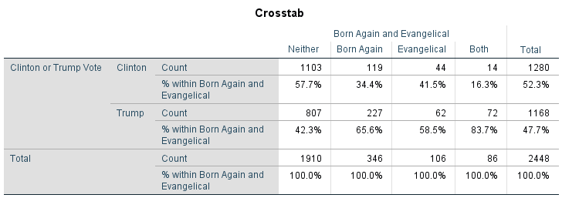
All of the results were statistically significant (Chi Square=116.877, p=0.000). Across the board, individuals who identified as Born Again, Evangelical, or Both voted for Donald Trump at higher rates than individuals who did not identify as any of these religious labels For example, those who identified as Neither supported Clinton over Trump at rates of 57.7% and 42.3% respectively. Among Born Again identifiers, however, 65.6% voted for Trump, and only 34.4% voted for Clinton. This pattern was clear in all categories, but interestingly, Evangelicals voted for Trump at slightly lower rates than Born Again identifiers, 58.5% versus 65.6%.
In order to identify the relationship between Evangelicals and Born Again identifiers and political ideology, I ran a cross-tabulation between bornagain_and_evangelical and political_ideology. The analysis yielded the following results:
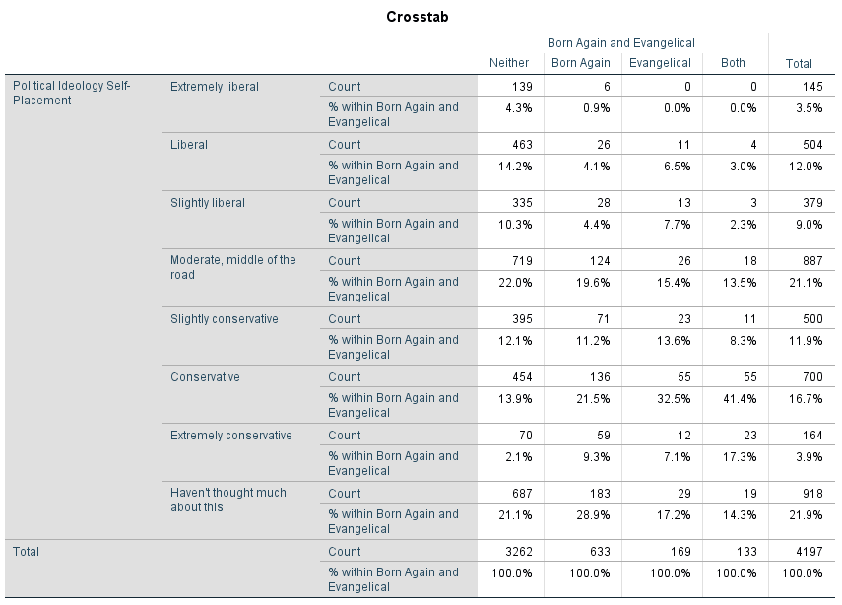
All of the results were statistically significant (Chi Square=382.268, p=0.000). In general, individuals who identify as Born Again, Evangelical, or Both also identify with the right side of the political ideology spectrum at higher rates than Neither identifiers. Individuals who identified with the three religious labels were more likely to identify as “Conservative” rather than “Slightly conservative” or “Extremely conservative.” For example, Evangelicals identified as “Slightly conservative” at a 13.6% rate, “Conservative” at a 32.5% rate, and “Extremely conservative” at only a 7.1% rate. While the three religious variables identified with the conservative labels a plurality of the time, surprisingly high percentages of each religious label identified as “Moderate, middle of the road” and “Haven’t thought much about this.”
Similar to the way the religious variables increased identification with the right side of the ideological spectrum, all three categories of religious identification increased levels of identification with the Republican Party in the cross-tabulation between party_identification and bornagain_or_evangelical.
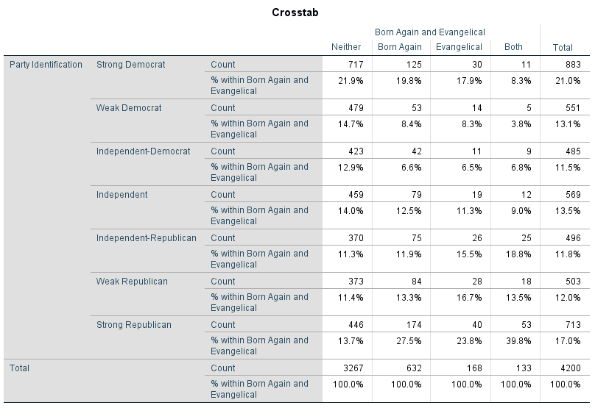
These results were also all statistically significant (Chi Square=191.672, p=0.000). Whereas the three religious groups were not as likely to identify as “Extremely conservative” as they were to identify as “Conservative,” they were much more likely to identify as “Strong Republican,” the farthest category to the right, than they were to identify as “Weak Republican” or “Independent-Republican.” The three religion labels identified with all of the Republican identification categories at higher rates than the rest of the population. For example, while only 13.7% of respondents who identified as “Neither” identified as “Strongly Republican,” 27.5% of Born Again identifiers and 23.8% of Evangelical identifiers identified as Strong Republicans. A notable exception in the data is the presence of Strong Democrat identifiers in the three religion categories. Among Born Again identifiers and Evangelical identifiers, 19.8% and 17.9% identified as Strong Democrats, respectively. These levels of identification are similar to the 21.9% level seen in the Neither category of religious identification.
Once I ran the basic cross-tabulations to identify the relationship between the religion variables and vote choice, political party identification, and political ideology, I ran four more cross-tabulations analyzing the religion variables and vote choice while controlling for other variables. The first variable I controlled for was party_identification, resulting in the following data. A.
In general, individuals voted largely along party lines. Unfortunately, only the Weak Democrat section of the cross-tabulation was statistically significant (Chi Square=22.442, p=0.000). In this section, Born Again and Both identifiers supported Trump at a much higher rate than the neither category. Interestingly, Clinton enjoyed 100% supported among the Evangelicals in the Weak Democrat section.
My next cross-tabulation controlled for the variable political_ideology with evangelical. I used evangelical. The cross tabulation produced the following results:

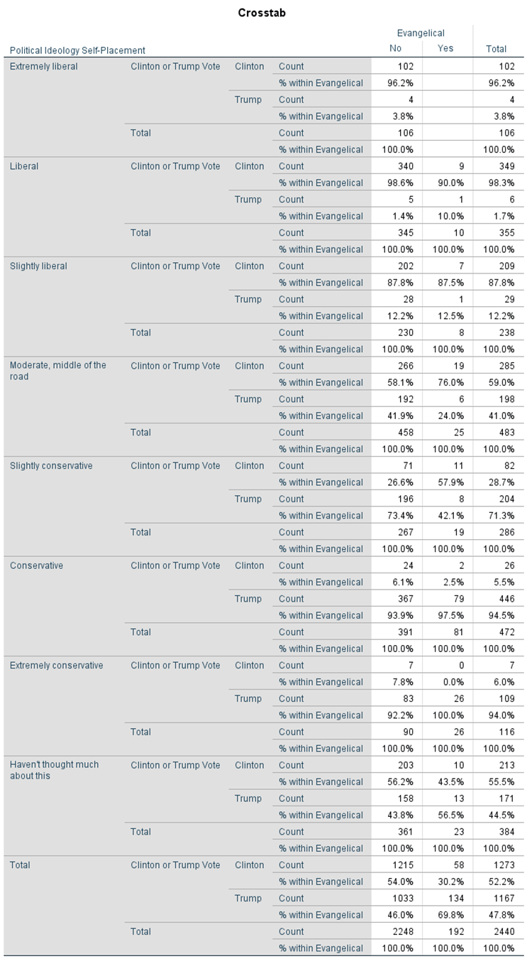
In general, Born Again and Both increased support for Trump in all categories. Only two sections on this cross-tabulation are statistically significant—”Slightly Conservative” (Chi Square=9.746, p=0.021) and “Haven’t thought much about this” (Chi Square=16.504, p=0.001). Clinton enjoyed an advantage among Evangelicals in every category except Conservative and Extremely Conservative.
The third cross-tabulation controlling for a third variable controlled for immigration_level. The following cross-tabulation only includes the variable evangelical instead of the variable bornagain_and_evangelical because evangelical provided the clearest example of the overall trend across the three religion variables. The analysis generated the following results:
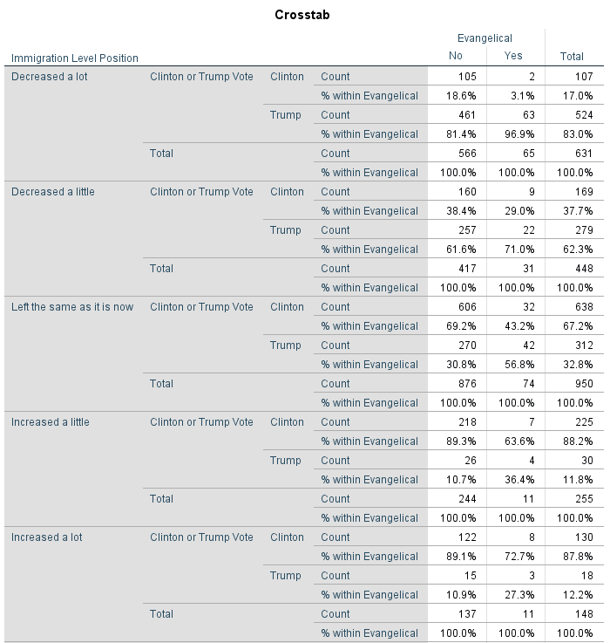

All of the results were significant at the following levels: Decreased a lot: (Chi Square= 12.271, p=0.007), Decreased a little: (Chi Square=8.162, p=0.043), Left the same as it is now: (Chi Square=41.878, p=0.000), Increased a little: (Chi Square=34.680, p=0.000), and, Increased a lot: (Chi Square=23.843, p=0.000). The results show that among the Neither identifiers, support for Clinton increases as support for more immigration increases, while support for Trump increases as support for more immigration decreases. For example, Neithers who wanted immigration increased a lot favored Clinton 89.1% to 10.9%. Neithers in the category for those who wanted immigration decreased a lot favored Trump 81.4% to 18.6%. Once the Evangelical variable was factored in however, support for Clinton decreased and support for Trump increased in every category of immigration level position. Neither identifiers in the “Left the same as it is now” category favored Clinton by a 38.4% margin (69.2% to 30.8%), but this “left the same as it is now” relationship flips in favor of Trump by a 13.6% margin (56.8% to 43.8%) in the Evangelical religious label category.
The final cross-tabulation I ran controlled for health_care_position. The analysis yielded the following results:
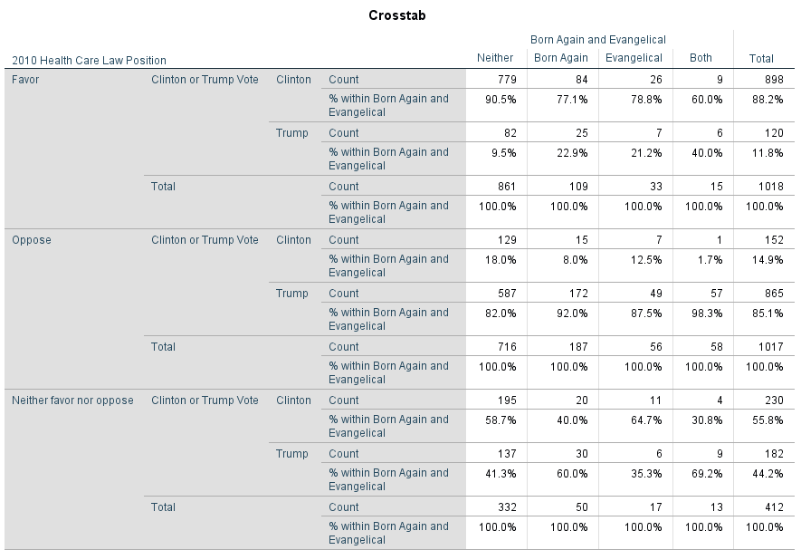
These results were statistically significant at the following levels: Favor: (Chi Square=31.572, p=0.000), Oppose: (Chi Square=20.605, 0.000), and Neither favor nor oppose: (Chi Square=10.071, p=0.018). Among individuals who did not identify as Evangelical or Born Again, those who favored the 2010 healthcare law overwhelmingly supported Hillary Clinton (90.5% to 9.5%). Neithers who opposed the 2010 healthcare law overwhelmingly supported Donald Trump, but not at as high of a level as Clinton experienced with the “favor” category (82.0% to 18.0%). In the “Neither Favor Nor Oppose” category, Clinton enjoyed a 17% advantage. Once the Evangelical, Born Again, and Both variables were introduced, support for Trump increased across all categories except one. For example, Neither identifiers who favored the 2010 health care law voted for Clinton at a 90.5% rate, but individuals who identified as Born Again, Evangelical, or Both and favored the 2010 health care law voted for Clinton at rates of 77.1%, 78.8%, and 60.9% respectively. An interesting exception in the data is that individuals who identified as Evangelical and neither favored not opposed the 2010 health care law favored Clinton by a 29.4% margin (64.7% to 35.3%).
Discussion
Following the statistical analysis, one could say that the first hypothesis, “In a study of voters in the United States, those who identify as Evangelical, Born Again, or Both will be more likely to have voted for Donald Trump in the 2016 presidential election than those who do not identify as Evangelical, Born Again, or Both” was supported. Individuals who identified with one of these religious labels were much more likely to vote for Trump than those who did not identify with any of the Evangelical labels. Support for Trump increased by at least 16% in every religious category compared to the Neither identifiers, while the Both category nearly doubled the Neither category, 42.3%-82.7%. Clearly, Evangelical Christianity did have an impact on vote choice in the 2016 election by making individuals who identified with the Evangelical Christian labels support Trump at much higher levels than Clinton.
The statistical analysis also supported the second and third hypotheses: “In a study of voters in the United States, those who identify as Evangelical, Born Again, or Both will be more likely to identify as conservative than those who do not identify as Evangelical, Born Again, or Both” and “In a study of voters in the United States, those who identify as Evangelical, Born Again, or Both will be more likely to identify with the Republican Party than those who do not identify as Evangelical, Born Again, or Both.” Interestingly, Evangelicals do not identify themselves as strong ideologues, but they do identify themselves as strong partisans. They are more likely to identify as Conservative than Extremely Conservative, but they are far more likely to identify as Strong Republicans or Strong Democrats than they are to identify as a weak-partisan or an independent-partisan. Regarding political ideology identification, a significant portion of respondents said they “hadn’t thought much about this.” These results agree with the work of Niemi and Weisberg who asserted that large portions of the electorate simply do not think in ideological terms but still hold stable views political parties throughout their lives. Large parts of the Evangelical Christian electorate did not think about their ideology, but they still had high levels of partisan identification. Regardless of the fact that many Evangelicals do not think about their ideology, Evangelical Christians as a whole will still be extremely likely to support conservative and Republican candidates in the future due to their high levels of identification as conservatives and strong Republicans.
Both the fourth and fifth hypotheses of “In a study of voters in the United States, those who identify as Evangelical, Born Again, or Both will be more likely to have voted for Donald Trump in the 2016 presidential election than those who do not identify as Evangelical, Born Again, or Both in all categories of political party identification” and “In a study of voters in the United States, those who identify as Evangelical, Born Again, or Both will be more likely to have voted for Donald Trump in the 2016 presidential election than those who do not identify as Evangelical, Born Again, or Both in all categories of political ideology identification” were supported by the statistical analysis as well. While political party identification seemed to overpower the religion variables in all categories—meaning that party identification is predominant to religion—only the “Weak Democrat” category was statistically significant. This could be the result of insufficient amounts of data. The religion variables increased support for Trump when political ideology was controlled for, but only the “Slightly conservative” and “Haven’t thought much about this” sections were statistically significant. Because so few of the results were significant, one cannot draw too many conclusions based on the data.
Finally, the statistical analyses supported the sixth and seventh hypotheses, “In a study of voters in the United States, those who identify as Evangelical, Born Again, or Both will be more likely to have voted for Donald Trump in the 2016 presidential election than those who do not identify as Evangelical, Born Again, or Both at all levels of preference for increasing or decreasing immigration” and “In a study of voters in the United States, those who identify as Evangelical, Born Again, or Both will be more likely to have voted for Donald Trump in the 2016 presidential election than those who do not identify as Evangelical, Born Again, or Both, even when position on the 2010 health care law is controlled for.” For the immigration issue position, identification with any of the religious variables increased support for Trump across all categories of policy preference. The category “Left the same as it is now” even flipped from Trump to Clinton once the religion variables were factored in. For the 2010 health care law issue position, identification with any of the religious variables increased support for Trump in all categories except for one—Evangelicals who neither favored nor opposed the law favored Hillary Clinton by a 29.4% margin. The fact that the religious variables created more support for Trump shows that an individual’s identification with Evangelical Christianity can be a more powerful factor in his vote choice than his issue positions. This could suggest that religious values and beliefs predominate issue positions.
A notable trend in the data is the differences between those who identify as either Evangelical or Born Again and those who identify as Both. The Both identifiers were consistently more partisan and more ideological than the other identifiers. Predictably, their partisan support went to the Republican Party, and their ideological identifications tilted heavily towards the conservative end of the spectrum. In the first cross-tabulation between clinton_or_trump_vote and bornagain_or_evangelical, Both identifiers supported Trump 84.7%-16.3%, 18.1 percentage points higher than the second highest level of support for Trump held by Evangelical identifiers. In the second cross-tabulation between bornagain_or_evangelical and political_ideology, 67% of Both identifiers also identified as either Slightly conservative, Conservative, or Extremely conservative, compared to 53.2% of Evangelical identifiers who had the second-highest level of conservative identification. Additionally, only 14.3% of Both identifiers said that they had not thought much about their political ideology, while 28.9% of Born Again identifiers and 17.2% of Evangelical identifiers said they had not thought much about it. This shows that individuals who think of themselves as both Born Again and Evangelical both think about their political ideology more often than others and identify as conservative at higher rates than others.
The third cross-tabulation between party_identification and bornagain_or_evangelical provided more evidence for the existence of this trend. While all three religious variables identified most strongly with the three Republican categories—Independent Republican, Weak Republican, and Strong Republican—Both identifiers identified as Republicans at a 72.1% rate, while Evangelicals identified as Republican at a 56% rate, and Born Again identifiers identified as Republicans at a 52.7% rate. Both identifiers were also most likely to identify as Strong Republicans at a 39.8% rate, compared to 27.5% for Born Again and 23.8% for Evangelical. Individuals in the Both category were also much less likely to identify as Strong Democrat—8.3% compared to 19.8% for Born Again and 17.9% for Evangelical—or Independent. These results show that Both identifiers are more partisan than any of the other categories of religious identification. The reason for the differences between Both’s, Born Again’s, and Evangelical’s levels of identification with conservativism and the Republican Party is unclear, however, those who identified as Both may hold religious views that are more evangelical than those who identified as either Born Again or Evangelical.
There are multiple possible explanations for the trend in Evangelical Christians’ vote choice. A simple explanation is that Evangelical Christians simply identify with the Republican Party at higher rates than the rest of the population does. However, this explanation does not take into account political ideology, basic personal values, and issue positions. The literature on these topics describes how each of these things can impact an individual’s political party identification. A more complex explanation is that Evangelical Christians’ basic personal values are influenced by their religion’s foundational beliefs. Their basic personal values then impact their political ideologies and issue positions. Then, the Evangelical Christians’ ideologies and issue positions translate into higher identification with the Republican Party. Whereas the general population possibly does not think in ideological terms enough to go through this complex process and must therefore resort to the heuristic of political parties, the data show that Evangelical Christians who identified as both Evangelical and Born Again think in ideological terms at higher rates than the general population. Therefore, this explanation may be valid for that particular group.
Conclusion
It is clear that Evangelical Christianity played a significant role in the 2016 Presidential Election by influencing the vote choice of those individuals who held Evangelical Christian beliefs. It is clear that Evangelical Christians were more conservative, more Republican, and more likely to vote for Donald Trump than the general population. When party identification, political ideology, and issue positions were controlled for, Evangelical Christians were still more likely to vote for Donald Trump. It is not immediately clear why exactly Evangelicals identify and vote the way they do. Future studies should focus on mapping the basic personal values and core political beliefs of Evangelical individuals and identifying the foundational religious beliefs and values or Evangelical Christianity. A comparison of these two sets of variables and beliefs could be used to better determine why Evangelicals identify and vote the way they do. Additionally, future research should seek to examine the difference between those who identify as either Evangelical or Born Again and those who identify as Both. Distinguishing between the values and beliefs of these groups of identifiers could shed light on doctrinal differences between the groups that lead to Both identifiers being more partisan and ideological. Hopefully, this research and future research will uncover more exactly why Evangelical Christians vote the way they do.

References
Abramowitz, A. I., & Saunders, K. L. (1998). Ideological Realignment in the U.S. Electorate. The Journal of Politics, 634-652.
Bardes, B., & Oldendick, R. W. (2017). Public Opinion: Measuring the American Mind. London, UK: Rowman & Littlefield.
Buuri, A., & Maercker, A. (2014). Differences in prevalence rates of PTSD in various European countries explained by war exposure, other trauma and cultural value orientation. BMC Research Notes.
Goren, P., Schoen, H., Reifler, J., Scotto, T., & Chittick, W. (2016). A unified theory of value-based reasoning and U.S. public opinion. Political Behavior.
Huddy, L., Jervis, R., & Sears, D. (2003). Oxford Handbook of Political Psychology. New York: Oxford University Press.
Jackson, R. A., & Carsey, T. M. (2002). Group Effects on Party Identification and Party Coalitions across the United States. American Politics Research.
Leege, D. C., & Welch, M. R. (1989). Religious Roots of Political Orientations: Variations Among American Catholic Parishioners. The Journal of Politics, 137-162.
Niemi, R. G., & Weisberg, H. F. (1976). Controversies in American Voting Behavior. United States: W. H. Freeman and Company.
Schwartz, S. (2005). Basic Human Values: An Overview.
Schwartz, S. et al. (2014). Basic Personal Values Underlie and Give Coherence to Political Values: A Cross National Study in 15 Countries. Political Behavior, 899-930.
Sears, D. H. (2003). Oxford Handbook of Political Psychology. New York: Oxford University Press.
Wald, K., & Calhoun-Brown, A. (2018). Religion and Politics in the United States. London: Rowman and Littlefield.

