Student Academic Progress Assignment
Josh Layton

Setting
The course I’ve selected for my SAPA is my Piano I class. The class is comprised of four students. Two of my students are in ninth grade, and two are in eleventh grade. Three of my students identify as female and one identifies as male. None of my students are on IEPs or other improvement plans, but one student has been diagnosed with anxiety disorder. Three of my students are completing advanced diplomas, which require additional classes in preparation for higher education. One of my students is completing a standard diploma that does not require additional coursework. As far as ability, one of my students has exhibited advanced ability level and substantial prior knowledge regarding content. One of my students has shown tremendous improvement in ability from the beginning of class. One of my students exhibits fantastic energy and motivation and has shown lots of improvement in ability. However, this student sometimes struggles with staying focused and investing their energy into the task at hand. One of my students has struggled to reach the level that my other students have but has shown great motivation and effort for the entire course. All four of my students identify as white and none are English language learners. My students have a diverse range of interests. One of my students plays football and is in a band in their free time. Another is involved in theatre and marching band. One has shown interest in art and all have shown interest in specific genres of music, which has been helpful in engaging students in musical concepts and ideas. My class takes place in the band room, which has access to a whiteboard, TV, two pianos, and sound system. The students are arranged in a row of four facing the teacher and all students have access to an electronic keyboard. Students also have access to headphones in order to practice individually. The class period takes place every day from 12:41 to 3:11 every day. Typically, instruction involves breaking down piano pieces into smaller sections, such as playing each hand’s part separately or playing line-by-line. This allows me to check my students’ understanding individually to ensure proficiency at each activity before we move on to new material.
Content
The content I will be teaching in my SAPA is chord inversions. I have chosen this concept because my students have received an introduction to triad structure and by now have the ability to construct chords using the root, third, and fifth scale degrees of a key. They also are able to identify chord numbers in a progression using roman numerals. Inverting a chord is the process of moving the scale degrees within the chord to create different chord voicings. My students have already played inverted chords, and the next step will be identifying the inversions they are using. Learning these inversions will allow them to be able to play multiple chords within a key signature without having to move their hands long distances along the keyboard. It will also allow them to begin experimenting with new chord voicings, using different chord tones as the highest note in the chord. This new content aligns with the following SOL’s:
HMT.8 The student will identify diatonic scale degrees by
2. using upper-case and lower-case Roman numerals and chord abbreviations to designate
triad quality (M, m, d, A) and scale degree; and
3. identifying I, IV, and V chords as primary chords.
HMT.9 The student will demonstrate understanding of triadic structure by
1. identifying root, third, and fifth of a chord;
3. explaining triads by quality (M, m, d, A);
5. explaining and notating root-position, first-inversion, and second-inversion triads;
There are no relevant National Standards for the specific selected content.
Preassessment and Analysis
For my preassessment, I designed a quiz using google forms. The quiz is broken up into two types of questions: chord identification and inversion identification. The questions cover chords in the key of either C or G. Each student can score a maximum of 16 points on the assessment. The students each took the preassessment during class on March 9. The class average score was a 4 out of 16 or 25%. The lowest score from the preassessment was a 3 out of 16, with the highest being 5 out of 16. My students did not show consistent strengths or weaknesses on either of the two specific types of questions. The preassessment form can be found using this link:
https://docs.google.com/forms/d/e/1FAIpQLSeDbAvNbQQ9z7o3JeSHQQYYxnFL9PFyYl9SIrPHMzX9OUCfkA/viewform?usp=sf_link
A graph displaying my student’s preassessment scores can be found in Appendix A.
Literature Review
An instructional strategy I have begun to introduce and am implementing in my SAPA is use of technology. By using technology, I can provide my students with a different outlook on the product that they are putting forward. I believe this strategy will be effective for few reasons. One reason is that a few of my students have already responded well to watching YouTube tutorials on songs that interest them. Another reason is that a few students seem to struggle navigating the keyboard. Piano keys are sometimes confusing and can all look the same at first. If a student is having difficulty locating correct notes, it will elongate the process of learning a new concept on piano. By giving students another perspective on the notes they are playing by using technology as a visual representation, it may help eliminate some of the confusion. A few ways this could be accomplished are by using online electric piano software, or by using digital audio workshops like Ableton Live to project notes being played as MIDI samples. In both examples, my students will be able to see the distances between the notes they are playing and compare them with chord inversions represented by music staves. I believe the combination of these representations will help my students form connections between their hands on the keyboard and the music on the page or screen. According to a study conducted by Professor Wai-chung Ho for the British Journal of Educational Technology, twenty-one out of thirty music teachers who participated concluded that the integration of technology could improve music learning (Ho 2004). Another more recent study from the British Journal of Music Education involving nine participating music teachers concluded that use of technology presents opportunities to meet the diverse needs of students. The participating teachers concluded that the use of technology can also help facilitate more student-centered music classrooms (Wise, 2011).
Learning Goal
1. As a result of the lessons, students will be able to identify and construct triad chords in root position, first inversion, and second inversion.
2. As a result of the lessons, students will be able to identify chords within a progression using their root notes and roman numerals.
3. As a result of the lessons, students will increase their scores on the preassessment by a minimum of 15%.
Plan for Instruction
After reviewing my preassessment data, my pan for my instruction is to incorporate effective use of technology to effectively meet the needs of multiple different types of learners in the class. I believe that my class contains both visual and kinesthetic learners and using technology effectively will give me the opportunity to present content through a few different mediums. I will use Ableton Live recording equipment to give my students an opportunity to play chords on an instrument as well as visualize the notes being produce in a midi track. I will use Musictheory.net to give my students a guided reading containing visual representation of the keyboard and staff to present chord inversions. I will also use an interactive game on Theta Music trainer online to present the relationships between chords within a chord progression using roman numerals. My lesson plans can be found in Appendix B.
Post assessment and Analysis
My post assessment data shows improvement by each student on each type of question from the assessment. The lowest score increased from a 2 out of 16 to a 10 out of 16. The highest score is now a 14 out of 16. The average score increased from 4 out of 16 on the pretest to a 12.5 on the post test. This is an increase of 8.5 points, or 53%. My students also showed different levels of improvement on each type of question included in the pre and post assessments. The two types of questions on the assessment are questions that ask students to identify chord quality, and questions that ask students to identify inversion type. The two question types are indicated on the horizontal axis of each graph in the appendices for each student; for example, “Student 1 chord and Student 1 inversion.” Student scores on each question type are grouped by student, not by question. Students scores on chord identification increased from an average of 2.25 points out of 8 possible to 4.5 out of 8, or 25%. However, student scores on inversion identification increased from 1.75 points out of 8 possible to an average of 8 points. This equates to a 78% increase in average points for the inversion identification question. This data indicates that my instructional strategies used for teaching inversion identification were potentially more effective than those I that I used to teach chord identification.
Something that I did not anticipate was a clearly indicated strength of my students on the questions covering inversion positions. Each student scored a perfect 8 on these questions. My students did not score as highly on the other type of questions involving chord identification. While I am glad my students showed improvement, I believe the data shows that some of my instructional strategies worked better than others. If I were able to teach this lesson again, I will be able to take this data into consideration when planning how to introduce this content. This data has also been helpful in showing how well my students were able to apply the concepts we had already been working on in class. Of the two types of questions, my expectation was that my students would be more prepared for the chord identification questions because of their prior knowledge of keys and scale degrees. This was not the case, and the amount of time we spent reviewing each concept was reflected in the data for each type of question. A graph displaying my post assessment data can be found in Appendix C.
Reflection
While my students showed improvement from the preassessment, I believe if I did a few things differently they could have improved more. My students were clearly more confident on the questions that covered inversion positions, which tells me that some of my strategies were more effective than others. I planned to devote more instruction time and review towards the questions covering inversion positions, but my students ended up needing more support on the other question type. My anticipation was that due to my students’ prior introduction to chords within key signatures as well as scale degrees would prepare them for understanding the chord identification assessment questions. Something that potentially could have helped was more initial informal assessment on my part before the SAPA in order to gain a better idea of my students’ preparedness for specific content. Another thing I would do differently is provide even more structure in my lesson plans. In my instruction, I taught my students to think of the different chord shapes like snowmen. This trick was not something I planned on using as a strategy but seemed to give my students a visual tool that helped their understanding. I think this informal strategy was effective but was not included in the original structure of the lesson. I think I need to be more aware of which strategies are having the best effect on learning after each step of the process. If my students are reacting well to an instructional strategy, I need to be able to identify what works and how I can implement that strategy in other ways. In this example, my students appeared to need a visual or memorization tool in order to master a new concept. I believe if I was to restart this project, I would plan for more structured informal assessment to check the understanding of my students on each concept before the formal assessment. I believe this process was very helpful in showing me all the factors that contribute to a student’s learning. I will use the data analysis skills I learned from this project in conjunction with the tools I am developing in student teaching to become a well-rounded and prepared teacher.

References
Ho, W. C. (2004). Use of information technology and music learning in the search for quality
education. British journal of educational technology, 35(1), 57-67.
Wise, S., Greenwood, J., & Davis, N. (2011). Teachers' use of digital technology in secondary
music education: illustrations of changing classrooms. British Journal of Music
Education, 28(2), 117-134.

Appendix
A. 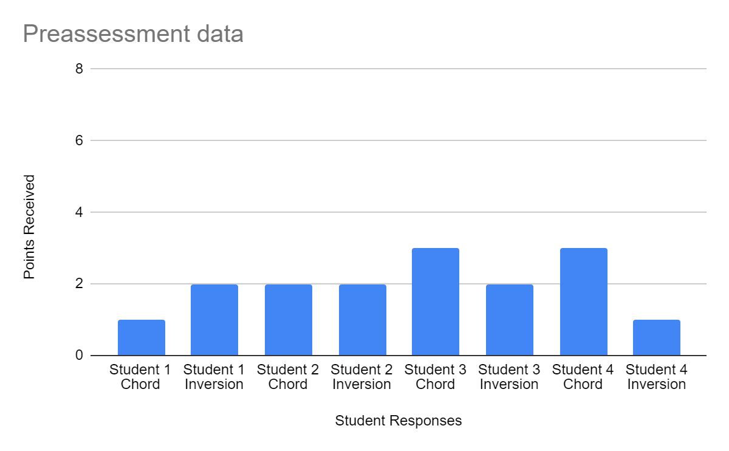

B.
Bridgewater College - Music Lesson Plan

Class/Ensemble: Piano I Date: 3/9/2020

National Standards and/or VA SOL(s):
HMT.8 The student will identify diatonic scale degrees by
2. using upper-case and lower-case Roman numerals and chord abbreviations to designate
triad quality (M, m, d, A) and scale degree; and
3. identifying I, IV, and V chords as primary chords.
HMT.9 The student will demonstrate understanding of triadic structure by
1. identifying root, third, and fifth of a chord;
3. explaining triads by quality (M, m, d, A);
5. explaining and notating root-position, first-inversion, and second-inversion triads;
There are no relevant National Standards for the specific selected content.

Materials/Equipment:
Keyboards, pianos, lesson books, whiteboard, chrome books, tv, sound system

Prior Knowledge:
Piano I students have received an introduction to chord progressions and inversions but have not yet gone into specific detail.

Objectives/Goals:
1. As a result of the lessons, students will be able to identify and construct triad chords in root position, first inversion, and second inversion.
2. As a result of the lessons, students will be able to identify chords within a progression using their root notes and roman numerals.
3. As a result of the lessons, students will increase their scores on the preassessment by a minimum of 15%.

Accommodations:
Students may use pianos instead of keyboards or headphones to practice material in a more comfortable setting.
Content/Procedures:

10 min  15 min  25 min  10 min  25 min | Sequence:  - Setup: allow time for students to prepare classroom materials and listen to afternoon announcements.  - Teacher will present preassessment google form. Students will complete preassessment using chrome books.  - Teacher will present review discussion on chord inversions. Students will use keyboards to play each chord inversion in sequence, repeating the pattern of root position, first inversion, and second inversion.  - Allow adequate time to put away classroom materials and disassemble the room.  - *Note: during this class period, students also completed a NAfME survey for Music in our Schools Month.

Closing:
Allow adequate time to put pianos, chairs, and stands away.

Assessment:
Students will complete a preassessment before the first lesson. After three lessons, the assessment will be administered again as a postassessment in order to analyze student data and improvement.

Bridgewater College - Music Lesson Plan

Class/Ensemble: Piano I Date: 3/10/2020

National Standards and/or VA SOL(s):
HMT.8 The student will identify diatonic scale degrees by
2. using upper-case and lower-case Roman numerals and chord abbreviations to designate
triad quality (M, m, d, A) and scale degree; and
3. identifying I, IV, and V chords as primary chords.
HMT.9 The student will demonstrate understanding of triadic structure by
1. identifying root, third, and fifth of a chord;
3. explaining triads by quality (M, m, d, A);
5. explaining and notating root-position, first-inversion, and second-inversion triads;
There are no relevant National Standards for the specific selected content.

Materials/Equipment:
Keyboards, pianos, lesson books, whiteboard, chrome books, tv, sound system

Prior Knowledge:
Piano I students have received an introduction to chord progressions and inversions but have not yet gone into specific detail.

Objectives/Goals:
1. As a result of the lessons, students will be able to identify and construct triad chords in root position, first inversion, and second inversion.
2. As a result of the lessons, students will be able to identify chords within a progression using their root notes and roman numerals.
3. As a result of the lessons, students will increase their scores on the preassessment by a minimum of 15%.

Accommodations:
Students may use pianos instead of keyboards or headphones to practice material in a more comfortable setting.
Content/Procedures:

10 min  15 min  20 min  25 min  10 min | Sequence:  - Setup: allow time for students to prepare classroom materials and listen to afternoon announcements.  - Warmup: Teacher will lead warmup exercise up the notes of the keyboard. Students will play major chords in sequence of inversion, moving the bottom note of each triad up for each different chord.  - Teacher will lead guided reading on musictheory.net on triad inversion. Students will identify the root notes of each chord presented and will determine the relationship of the inverted chords to the provided key signatures.  - Teacher will introduce the ear training game on musictheory.net. Students will listen to chords and review chord progressions using roman numerals to complete the exercises.  - Allow adequate time to put away classroom materials and disassemble the room.

Closing:
Allow adequate time to put pianos, chairs, and stands away.

Assessment:
Students will complete a preassessment before the first lesson. After three lessons, the assessment will be administered again as a postassessment in order to analyze student data and improvement.

Bridgewater College - Music Lesson Plan

Class/Ensemble: Piano I Date: 3/11/2020

National Standards and/or VA SOL(s):
HMT.8 The student will identify diatonic scale degrees by
2. using upper-case and lower-case Roman numerals and chord abbreviations to designate
triad quality (M, m, d, A) and scale degree; and
3. identifying I, IV, and V chords as primary chords.
HMT.9 The student will demonstrate understanding of triadic structure by
1. identifying root, third, and fifth of a chord;
3. explaining triads by quality (M, m, d, A);
5. explaining and notating root-position, first-inversion, and second-inversion triads;
There are no relevant National Standards for the specific selected content.

Materials/Equipment:
Keyboards, pianos, lesson books, whiteboard, chrome books, tv, sound system

Prior Knowledge:
Piano I students have received an introduction to chord progressions and inversions but have not yet gone into specific detail.

Objectives/Goals:
1. As a result of the lessons, students will be able to identify and construct triad chords in root position, first inversion, and second inversion.
2. As a result of the lessons, students will be able to identify chords within a progression using their root notes and roman numerals.
3. As a result of the lessons, students will increase their scores on the preassessment by a minimum of 15%.

Accommodations:
Students may use pianos instead of keyboards or headphones to practice material in a more comfortable setting.
Content/Procedures:

10 min  15 min  25 min  15 min  15 min  10 min | Sequence:  - Setup: allow time for students to prepare classroom materials and listen to afternoon announcements.  - Warmup: Teacher and students will continue the warmup exercise from the previous class, this time using a different major chord. Students will play same inversion sequence across the keyboard using different notes.  - Teacher will present Ableton Live activity. Teacher and students will take turn playing a chord on a midi keyboard without looking at the keyboard. Using the notes produced on the tv screen, students will identify the chord being played, the inversion, and the relationship of the chord to the provided key using roman numerals.  - Teacher will spend time reviewing material before the postassessment. Specific material that students will review will include identifying roots of inverted chords and defining the notation for first and second inversion.  - Teacher will distribute the postassessment. Students will complete the postassessment at the end of class after they have significantly reviewed the content covered by the previous three lessons.  - After taking the postassessment, students will disassemble the band room and put away their materials.

Closing:
Allow adequate time to put pianos, chairs, and stands away.

Assessment:
Students will complete a preassessment before the first lesson. After three lessons, the assessment will be administered again as a postassessment in order to analyze student data and improvement.

C.
